STORM WATER POLLUTION PREVENTION PLAN (SWPPP)

Project Title:

Project No.:

DOH NGPC File No.
Prepared by: Department of Transportation, Highways, Design Branch
Date:
Storm Water Pollution Prevention Plan (SWPPP)
Notice of General Permit Coverage (NGPC) File No.
Preparation Date

Table of Contents
Table of Contents 2
7.0 Preface 3
7.0.1 Notes for Contractor/HDOT Construction Personnel 3
7.2.1 Storm Water Team 4
7.2.2 Nature of Construction Activities Form C.6 6
7.2.3 Emergency Related Projects 7
7.2.4 Identification of Prime Contractor and Other Site Contractors 7
7.2.5 Sequence and Estimated Dates of Construction Activities 8
7.2.6.1 Property Boundary Maps 9
7.2.6.2 to 7.2.6.8 State Waters and BMP Maps 11
7.2.7 Construction Site Pollutants 13
7.2.8 –Sources of Non-Storm Water 15
7.2.9 –Buffer Documentation 16
7.2.10 Storm Water Control Measures 18
BMP Details 19
7.2.10.2 – Stabilization Practices 42
7.2.10.3 – Post Construction Measures 45
7.2.11.1 – Spill Prevention and Response Procedures 46
7.2.11.2 – Waste Management Procedures 47
7.2.12 – Procedures for Inspection, Maintenance, and Corrective Action 47
7.2.13 – Staff Training 49
7.2.14 – Documentation of Compliance with Safe Drinking Water Act Underground Injection Control (UIC) Requirements for Certain Subsurface Storm Water Controls 50
7.2.15 –Other State, Federal, or County Permits 51
7.2.16 –Other Information As Requested by the Director 52
7.2.17 Certification of the CWB SWPPP 53
7.2.18 Post-Authorization Additions to the SWPPP 54
7.4 Required SWPPP Modifications 54
13.0 Monthly Compliance Report Submittal Requirements 55
SWPPP Attachments 56
Attachment A – Contractor/Sub-Contractor Control Maps, Property Boundary Maps, State Waters and BMP Maps, and BMP Details (SWPPP Sections 7.2.4, 7.2.6.1,7.2.6.2 to 7.2.6.8 & 7.2.10) 56
Attachment B – HDOT SWPPP Training Log (SWPPP Section 7.2.13) 57
Attachment C - Construction Schedule (SWPPP Section 7.2.5) 59
Attachment D – Subcontractor Certifications/Agreements (SWPPP Section 7.2.4) 60
Oahu Attachment E1 – SWPPP Inspection Report Form for Oahu(SWPPP Section 7.2.12) Rev. 1/28/2015 61
Oahu Attachment E2 – Corrective Action Reports (SWPPP Section 7.2.12) Rev. 02/25/14 64
Oahu Attachment E3 – HDOT Highways Oahu Construction Discharge Response Flow Chart, Rev. 11/17/2015; HDOT Construction Discharge Report Form (SWPPP Section 7.2.12) Rev. 1/28/15 67
Oahu Attachment E4 – Monthly Compliance Report 74
Oahu Attachment E5 – Receiving State Waters Inspection Report for Individual NPDES Permits (SWPPP Section 7.2.12) Rev. 01/28/15 77
Kauai/Maui/Hawaii Attachment E1 – HDOT Inspection Report for Kauai, Maui, and Big Island 81
Attachment F – Spill Prevention and Response Procedures (SWPPP Section 7.2.11.1) 91
Attachment G – Waste Management Procedures (SWPPP Section 7.2.11.2) 96
Attachment H – Emergency Related Projects, Departures from Manufacturer’s Specifications for Fertilizers Containing Nitrogen or Phosphorus, Buffer Documentation, Documentation of Compliance with UIC Requirements, Other State/Federal/County Permits, Fugitive Dust Control Plan & Other Information as Requested by the Director (SWPPP Sections 7.2.3, 7.2.9, 7.2.14, 7.2.15, and 7.2.16) 103
Attachment I – Corrective Action Reports 106
Attachment J – Monthly Compliance Report 109
Attachment K – Post-Authorization Additions to the SWPPP 110
Attachment L – SWPPP Modification Log 111

7.0 Preface
The following documents are referenced throughout the SWPPP:
- Hawaii Administrative Rules, Chapter 11-55
- HDOT Construction Best Management Practices Field Manual
- Hawaii Standard Specifications for Road and Bridge Construction dated 2005 and applicable special provisions.

7.0.1 Notes for Contractor/HDOT Construction Personnel

- Items in red need to be updated by the Contractor once the project is awarded prior to construction. The Contractor shall be responsible for updating the SWPPP during construction.
- Items in blue should be done by the designer. Remove this note and blue font when preparing the SWPPP.

Contractor Staging/Storage Areas
- HDOT has permitted all outfalls and disturbed potential Contractor Staging/Storage Areas within the project limits as identified in the project’s Notice of Intent or NPDES Permit Application.
- The Contractor may use any disturbed area acceptable to the Engineer for Staging/Storage.
- Staging/Storage Areas outside disturbed areas or outside the project limits may require a new NPDES submittal. See permitting requirements in Section 209 of the Specifications and applicable Special Provisions.
Outfalls 1, 2, 3, 4, 5, 6, 7, and 8 discharge to nutrient or sediment impaired waters. The following applies to construction areas discharging to these outfalls:
- Construction BMPs shall be inspected weekly, and within 24 hours of any rainfall event of 0.25 inches or greater in a 24 hour period and daily during periods of prolonged rainfall. For more details see section 7.2.12 of this SWPPP.
- Immediately initiate and complete stabilization within 7 calendar days on areas of the site in which earth-disturbing activities have temporarily or permanently ceased. For more details see section 7.2.10.2 of the SWPPP.
Outfalls X, X, and X discharge to waters not impaired for nutrients or sediments. The following applies to construction areas discharging to these outfalls:
- Construction BMPs shall be inspected weekly. For more details see section 7.2.12 of this SWPPP.
- Immediately initiate and complete stabilization within 14 calendar days on areas of the site in which earth-disturbing activities have temporarily or permanently ceased. For more details see section 7.2.10.2 of the SWPPP.

7.2.1 Storm Water Team
The permittee shall assemble and oversee a “storm water team,” which is responsible for the development of the SWPPP, any later modifications to it, and for compliance with the requirements in the Notice of General Permit Coverage (NGPC) or Individual NPDES permit.
The SWPPP must identify the personnel (by name or position) that are part of the storm water team, as well as their individual responsibilities. Each member of the storm water team must have ready access to an electronic or paper copy of applicable portions of this permit, the most updated copy of the SWPPP, and other relevant documents or information that must be kept with the SWPPP.
The Contractor shall include their personnel information once the project is awarded.
1) Name: HDOT Engineer(Or Consultant)
Company: Hawaii Department of Transportation
Position: HDOT Engineer
Contact Number: (808)692-XXXX
Responsibilities: Develop SWPPP during the design process

2) Name:
Company: Hawaii Department of Transportation
Position: HDOT Resident Engineer
Contact Number: (808)xxx-xxxx
Responsibilities:

3) Name:
Company: Hawaii Department of Transportation
Position: HDOT Construction Project Engineer
Contact Number: (808)xxx-xxxx
Responsibilities:

4) Name:
Company: Hawaii Department of Transportation
Position: HDOT Construction Project Engineer
Contact Number: (808)xxx-xxxx
Responsibilities:

5) Name:
Company: Contractor
Position: Contractor Designated Representative
Contact Number: (808)xxx-xxxx
Responsibilities:

6) Name:
Company: Contractor
Position: Contractor
Contact Number: (808)xxx-xxxx
Responsibilities:

7) Name:
Company: Contractor
Position: Contractor
Contact Number: (808)xxx-xxxx
Responsibilities:
8) Name:
Company: Contractor
Position: Contractor
Contact Number: (808)xxx-xxxx
Responsibilities:

7.2.2 Nature of Construction Activities Form C.6

What is the function of the construction activity (Please check all applicable activity(ies))?
☐ Residential ☐ Commercial ☐ Industrial Road Construction ☐ Linear Utility
☐ Other (please specify):
For construction site estimates, see NOI Form C, Section C.3.

What is being constructed? The roadway, sidewalks, gutters, and Bridge End Posts are being reconstructed. The median is being landscaped.

Describe the scope of work and major construction activities covered in this NOI, including baseyards and staging areas. Include only project areas where the locations of impervious structures are known; project areas where the final grades are known; and work areas that will be performed by one (1) general contractor. A separate NOI will be required for all other project areas. (Note: Per Section 209 of the specifications and applicable special provisions, the maximum surface area of earth material which may be exposed at any time is 300,000 square feet.)
Construction activities include reconstructing the travelway, repairing sidewalks and gutters, median landscaping, and upgrading bridge endposts. The locations of the staging and storage areas may be changed by the Contractor depending on his construction means and methods. The Contractor shall submit to the Engineer the locations of his staging and storage areas once the project is awarded for review and acceptance.

7.2.3 Emergency Related Projects

Not Applicable
☐ Applicable (If this box is checked, provide additional information as described below)
If conducting earth-disturbing activities in response to a public emergency (see section 1.3.), the permittee shall document the cause of the public emergency (e.g., natural disaster, extreme flooding conditions, etc.), information substantiating its occurrence (e.g., state disaster declaration or similar state declaration), and a description of the construction necessary to reestablish effected public services. The declaration of emergency or imminent threat to public health is required to be from the state governor or the director. See Attachment H for additional information.

7.2.4 Identification of Prime Contractor and Other Site Contractors
The SWPPP must include a list of both the prime contractor and all other contractors (e.g., sub-contractors) who will be engaged in construction activities at the site, and the areas of the site over which each contractor has control. List prime contractor and sub-contractors below and attach map showing areas of control in Attachment A. Complete and attach a Subcontractor Certification/Agreement in Attachment D.
(General Contractor Company Name) The general contractor information will be submitted at least 30 calendar days before the start of construction activities.
(General Contractor Contact Person Name)
(General Contractor Mailing Address)
(General Contractor Mailing City)
(General Contractor Mailing State and Zip Code)
(General Contractor Telephone Number)
(General Contractor Email Address)

(Sub-Contractor #1 Company Name, as needed)
(Sub-Contractor Contact Person Name)
(Sub-Contractor Mailing Address)
(Sub-Contractor Mailing City)
(Sub-Contractor Mailing State and Zip Code)
(Sub-Contractor Telephone Number)
(Sub-Contractor Email Address)

(Sub-Contractor #2 Company Name, as needed)
(Sub-Contractor Contact Person Name)
(Sub-Contractor Mailing Address)
(Sub-Contractor Mailing City)
(Sub-Contractor Mailing State and Zip Code)
(Sub-Contractor Telephone Number)
(Sub-Contractor Email Address)

(Sub-Contractor #3 Company Name, as needed)
(Sub-Contractor Contact Person Name)
(Sub-Contractor Mailing Address)
(Sub-Contractor Mailing City)
(Sub-Contractor Mailing State and Zip Code)
(Sub-Contractor Telephone Number)
(Sub-Contractor Email Address)

Attach maps showing areas of Contractor/Subcontractor Control in Attachment A.

Complete and attach a Subcontractor Certification/Agreement in Attachment D.

7.2.5 Sequence and Estimated Dates of Construction Activities

In Attachment C, attach the proposed construction schedule which shall include, at a minimum:
The Contractor shall submit to the Engineer an update of the dates once the project is awarded for inclusion in the SWPPP.

Installation of storm water control measures, and when they will be made operational, including an explanation of how the sequence and schedule for installation of storm water control measures complies with section 5.1.1.3.1. and of any departures from manufacturer specifications pursuant to section 5.1.1.3.2., including removal procedures of the storm water control measures after construction has ceased.

Commencement and duration of earth-disturbing activities, including clearing and grubbing, mass grading, site preparation (i.e., excavating, cutting and filling), final grading, and creation of soil and vegetation stockpiles requiring stabilization.

Cessation, temporarily or permanently, of construction activities on the site, or in designated portions of the site.

Final or temporary stabilization of areas of exposed soil. The dates for stabilization must reflect the applicable deadlines to which the permittee is subject to in section 5.2.1.

Removal of temporary storm water conveyances/channels and other storm water control measures, removal of construction equipment and vehicles, and cessation of any pollutant-generating activities.

7.2.6.1 Property Boundary Maps
Boundaries of the property and of the locations where construction activities will occur. Attach, title, and identify all maps (pdf - minimum 300 dpi) listed below, in Attachment A.
- Legal boundaries of the project. See NOI, Form C, Section C.8
- Locations where earth-disturbing activities will occur, noting any sequencing of construction activities. See NOI, Form C, Section C.8
- Pre-Construction Topography including approximate slopes and drainage patterns for the entire Facility/Project site to the receiving storm water drainage system (if applicable) or to the receiving State water(s) (with flow arrows). Note areas of steep slopes (15% or greater in grade). See NOI, Form C, Section C.8
- During-Construction Topography (after major grading activities) including approximate slopes and drainage patterns for the entire Facility/Project site to the receiving storm water drainage system (if applicable) or to the receiving State water(s) (with flow arrows) Note areas of steep slopes (15% or greater in grade). See NOI, Form C, Section C.8
- Post-Construction Topography including approximate slopes and drainage patterns for the entire Facility/Project site to the receiving storm water drainage system (if applicable) or to the receiving State water(s) (with flow arrows). Note areas of steep slopes (15% or greater in grade). See NOI, Form C, Section C.8
- Locations where sediment, soil, or other construction materials will be stockpiled 7.2.6.1c.
See SWPPP Attachment A. Stockpile locations may be changed by the Contractor depending on his construction means and methods. The Contractor shall submit to the Engineer for his review and acceptance the locations of stockpiles once the project is awarded and will be included in the SWPPP. The Contractor shall submit to the Engineer for his review and acceptance any updates/changes to stockpile areas during construction for inclusion in the SWPPP.
- Locations of any contaminated soil or contaminated soil stockpiles 7.2.6.1d. No areas of contaminated soil are expected to be encountered in the area. If any areas are encountered, the locations will be included in the SWPPP.
- Locations of any crossings of state waters 7.2.6.1e. Nuuanu Stream is shown in NOI Form C, Attachment A-1.
- Designated points on the site where vehicles will exit onto paved roads 7.2.6.1f. See SWPPP Attachment A. Stabilized entrance locations may be changed by the Contractor depending on his construction means and methods. The Contractor shall submit to the Engineer the locations of stabilized entrances once the project is awarded for his review and acceptance and will be included in the SWPPP. The Contractor shall submit to the Engineer for his review and acceptance any updates/changes to stabilized entrances during construction for inclusion in the SWPPP.
- Location(s) of impervious structures (including buildings, roads, parking lots, etc.) after construction is completed 7.2.6.1g. See NOI, Form C, Section C.8
- Locations of construction support activity areas covered by this permit 7.2.6.1h. See SWPPP Attachment A. The locations of the staging and storage areas may be changed by the Contractor depending on his construction means and methods. The Contractor shall submit to the Engineer the locations of his staging and storage areas for his review and acceptance once the project is awarded. The Contractor shall submit to the Engineer any updates/changes to staging and storage areas during construction for his review and acceptance and inclusion in the SWPPP.

7.2.6.2 to 7.2.6.8 State Waters and BMP Maps

Attach, title, and identify all maps (pdf - minimum 300 dpi) listed below, in Attachment A.
Please reference which maps account for the features listed below.
- Locations of all state waters, including wetlands, that exist within or in the immediate vicinity of the site and indicate which waterbodies are listed as impaired 7.2.6.2. See NOI, Form C, Section C.8
- The boundary lines of any natural buffers provided consistent with section 5.1.2.1.1, 7.2.6.3.
Natural buffers are not feasible on Vineyard Boulevard in the vicinity of Nuuanu Stream. See Section 7.2.9
- Topography of the site, existing vegetative cover (e.g., forest, pasture, pavement, structures), and drainage pattern(s) of storm water onto, over, and from the site property before and after major grading activities 7.2.6.4. See NOI, Form C, Section C.8
- Storm water discharge locations, including: a) Locations of any storm drain inlets on the site and in the immediate vicinity of the site to receive storm water runoff from the project; See NOI, Form C, Section C.8
and b) Locations where storm water will be discharged to state waters (including wetlands)7.2.6.5. See NOI, Form C, Section C.8

- Locations of all potential pollutant-generating activities identified in section 7.2.7, 7.2.6.6.
See SWPPP Attachment A (Construction Activity BMP Map)
- Locations of storm water control measures 7.2.6.7. See SWPPP Attachment A. The Contractor may change the locations of storm water control measures by construction activity and construction sequence depending on his construction means and methods. The Contractor shall submit changes to the Engineer for his review and acceptance once the project is awarded. The Contractor shall submit a separate map for each phase of construction which changes the drainage pattern. The Contractor shall submit to the Engineer for his review and acceptance any updates/changes to storm water control measures during construction for inclusion in the SWPPP. (Include maps by Construction Activity and Construction Sequence)
- Locations where chemicals will be used and stored 7.2.6.8. For locations where chemicals will be used, see SWPPP Attachment A Construction Activity BMP Map. The table below shows possible chemicals which may be used on site and which construction activity they are associated with. The locations where chemicals may be used and stored may be changed by the Contractor depending on his construction means and methods. The Contractor shall submit to the Engineer for his review and acceptance any updates/changes to locations where chemicals will be used and stored during construction for inclusion in the SWPPP.
Chemical | Location | Major Construction Activity
Hydraulic oils/ fluids | - Vehicle Refueling area  - Leaks from broken hoses on equipment  - Vehicles shall be maintained off site. If a maintenance area is necessary on-site, the Contractor shall submit to the Engineer the locations and BMPs for his review and acceptance for inclusion in the SWPPP. | Roadway Demolition and Construction, Landscaping
Antifreeze/Coolants | - Vehicle Refueling area  - Leaks from broken hoses on equipment  - Vehicles shall be maintained off site. If a maintenance area is necessary on-site, the Contractor shall submit to the Engineer the locations and BMPs for his review and acceptance for inclusion in the SWPPP. | Roadway Demolition and Construction, Landscaping
Glue, Adhesives | - Roadway construction | Roadway Demolition and Construction
Concrete Curing Compounds/ Form Release Oils | - Roadway construction involving concrete | Roadway Demolition and Construction
Pesticides | - Landscaping areas | Landscaping
Herbicides | - Landscaping areas | Landscaping
Insecticides | - Landscaping areas | Landscaping
Fertilizers | - Landscaping areas | Landscaping

7.2.7 Construction Site Pollutants

For each pollutant-generating activity, an inventory of pollutants or pollutant constituents (e.g., sediment, fertilizers and/or pesticides, paints, solvents, fuels) associated with that activity, which could be exposed to rainfall and could be discharged from the construction site. The Contractor shall take into account where potential spills and leaks could occur that contribute pollutants to storm water discharges. The Contractor shall also document for the Engineer’s review and acceptance any departures from the manufacturer’s specifications for applying fertilizers containing nitrogen and phosphorus, as required in Section 5.3.5.1 under Attachment H.
All solid waste shall be disposed of at DOH, Solid and Hazardous Waste Branch (SHWB), Solid Waste Section (SWS) permitted facilities. If not, contact the SHWB-SWS at (808) 586-4226 as additional permits may be required.

Source/Material | Description of How Potential Pollutant Source will be Prevented from Discharging with  Storm Water Runoff | Major Construction Activity
Construction debris, green waste, general litter | - See Section 7.2.10 for Site Specific BMPs | Roadway Demolition and Construction, Landscaping
Materials associated with the operation and maintenance of equipment, such as oil, fuel, and hydraulic fluid leakage | - See Section 7.2.10 for Site Specific BMPs | Roadway Demolition and Construction, Landscaping
Soil erosion from the disturbed areas | - See Section 7.2.10 for Site Specific BMPs | Roadway Demolition and Construction, Landscaping
Sediment from soil stockpiles | - See Section 7.2.10 for Site Specific BMPs | Roadway Demolition and Construction, Landscaping
Emulsified asphalt or prime/tack coat | - See Section 7.2.10 for Site Specific BMPs | Roadway Demolition and Construction, Landscaping
Materials associated with painting, such as paint and paint wash solvent | - See Section 7.2.10 for Site Specific BMPs | Roadway Demolition and Construction, Landscaping
Industrial chemicals, fertilizers, and/or pesticides | - See Section 7.2.10 for Site Specific BMPs | Roadway Demolition and Construction, Landscaping
Hazardous waste (Batteries, Solvents, Treated Lumber, etc.) | - See Section 7.2.10 for Site Specific BMPs | Roadway Demolition and Construction, Landscaping
Metals and Building Materials | - See Section 7.2.10 for Site Specific BMPs | Roadway Demolition and Construction, Landscaping
Existing Pollution Sources | - See Section 7.2.10 for Site Specific BMPs | Roadway Demolition and Construction, Landscaping
Other (Contaminated Soil) | - See Section 7.2.10 for Site Specific BMPs | Roadway Demolition and Construction, Landscaping

7.2.8 –Sources of Non-Storm Water
The SWPPP must also identify all sources of non-storm water and information, including, but not limited to, the design, installation, and maintenance of the control measures to prevent its discharge.
All solid waste shall be disposed of at DOH, Solid and Hazardous Waste Branch (SHWB), Solid Waste Section (SWS) permitted facilities. If not, the Contractor shall contact the SHWB-SWS at (808) 586-4226 and notify the Engineer for his agreement the disposal locations. Additional permits may be required.

Source | Description of How Potential Non-Storm Water Pollution Source will not be Discharged to State Waters | Major Construction Activity
Dust Control Water | - See Section 7.2.10 for Site Specific BMPs | Roadway Demolition and Construction, Landscaping
Concrete Truck Wash Water | - See Section 7.2.10 for Site Specific BMPs | Roadway Demolition and Construction, Landscaping
Sediment Track Out | - See Section 7.2.10 for Site Specific BMPs | Roadway Demolition and Construction, Landscaping
Irrigation Water | - See Section 7.2.10 for Site Specific BMPs | Roadway Demolition and Construction, Landscaping
Hydrotesting Effluent | - See Section 7.2.10 for Site Specific BMPs | Roadway Demolition and Construction, Landscaping
Dewatering Effluent | - See Section 7.2.10 for Site Specific BMPs | Roadway Demolition and Construction, Landscaping
Saw-cutting Slurry | - See Section 7.2.10 for Site Specific BMPs | Roadway Demolition and Construction, Landscaping
Concrete Curing Water | - See Section 7.2.10 for Site Specific BMPs | Roadway Demolition and Construction, Landscaping
Plaster Waste Water | - See Section 7.2.10 for Site Specific BMPs | Roadway Demolition and Construction, Landscaping
Water-Jet Wash Water | - See Section 7.2.10 for Site Specific BMPs | Roadway Demolition and Construction, Landscaping
Sanitary/Septic Waste | - See Section 7.2.10 for Site Specific BMPs | Roadway Demolition and Construction, Landscaping

7.2.9 –Buffer Documentation

If required to comply with section 5.1.2.1. because a state water is located within 50 feet of the project’s earth disturbances, describe which compliance alternative has been selected for the site, and comply with any additional requirements to provide documentation in Section 5.1.2.1. Delineate, and clearly mark off, with flags, tape, or other similar marking device all natural buffer areas. Use velocity dissipation devices if necessary to prevent erosion caused by storm water within the buffer. Ensure all discharges are first treated by erosion and sediment controls. Note: Buffer compliance requirements must be maintained until construction on the area discharging to the buffer is complete, and the area is restored and stabilized (as applicable).

☐ Option 1
Provide and maintain a 50-foot undisturbed natural buffer and sediment control.
Note: If the earth disturbances are located 50 feet or further from a state water and have installed sediment control, then the permittee has complied with this alternative. If the buffer is located outside State Highways Right of Way, include written permission from the owner of the land in SWPPP Attachment H.

Width of Buffer feet

☐ Option 2
Provide and maintain an undisturbed natural buffer that is less than 50 feet and double sediment control (e.g., double perimeter control) spaced a minimum of 5 feet apart.

Width of Buffer feet

☐ Option 3
If it is infeasible to provide and maintain an undisturbed natural buffer of any size, the permittee shall provide and maintain double sediment control (e.g., perimeter control) spaced a minimum of 5 feet apart and complete stabilization within 7 calendar days of the temporary or permanent cessation of earth-disturbing activities. Provide documentation why it is infeasible to provide buffer of any size in Attachment H.

☐ Exception 1
There is no discharge of storm water to state waters through the area between the site and any state waters located within 50 feet of the site, the permittee is not required to comply with the requirements in this section. This includes situations where control measures have been implemented, such as a berm or other barrier, that will prevent such discharges.

Exception 2
For “linear construction projects” where “linear construction projects” means the construction of roads, bridges, conduits, substructures, pipelines, sewer lines, towers, poles, cables, wires, connectors, switching, regulating and transforming equipment and associated ancillary facilities in a long, narrow area, the permittee is not required to comply with the requirements in this section if site constraints (e.g., limited right-of-way) prevent the permittee from meeting any of the compliance alternatives in section 5.1.2.1.1., provided that, to the extent practicable, the permittee limit disturbances within 50 feet of state waters and/or the permittee provide erosion and sediment controls to treat storm water discharges from earth disturbances within 50 feet of the state water. The permittee shall also document below the rationale as to why it is infeasible to comply with the requirements in section 5.1.2.1.1., and describe any buffer width retained and/or erosion and sediment controls installed below.

Vineyard Boulevard crosses Nuuanu Stream at Nuuanu Bridge. Grass strips in the vicinity of the bridge do not intercept runoff from the disturbed area since there is a raised curb and sidewalk adjacent to the stream. The sidewalk in the vicinity of the stream is graded towards the concrete gutter in the roadway. Disturbed areas discharging to the stream are conveyed by HDOT’s MS4 system directly into Nuuanu Stream. Drainage Inlets will be protected using Inlet Protection BMPs.

☐ Exception 3
The following disturbances within 50 feet of a state water are exempt from the requirements in this Part: construction approved under a CWA 404 permit; or construction of a water-dependent structure or water access area (e.g., pier, boat ramp, trail).
The permittee shall document in the SWPPP if any of the above disturbances will occur within the buffer area on the site below.
N/A

7.2.10 Storm Water Control Measures
Please refer to Hawaii Department of Transportation Construction Best Management Practices Field Manual dated January 2008 and Supplemental Sheets. For any conflicting requirements between the Manual and applicable bid documents, the applicable bid documents will govern. Should a requirement not be clearly described within the applicable bid documents, the Contractor shall notify the Engineer immediately for interpretation. For the purposes of clarification under “applicable bid documents” include the construction plans, standard specifications, Special Provisions, Permits, and the SWPPP.

BMP Details
Complete the table below. Note: Bold text in the table are requirements of HAR 11-55. The Designer will provide an installation detail of all proposed BMPs (From HDOT Construction BMP Field Manual) identified in Section 7.2.6.7, including the proposed BMPs that will be used to mitigate the potential pollutants identified in Sections 7.2.7 and 7.2.8. Attach the details and design calculations, if applicable, in SWPPP Attachment A(7.2.10.1a). The Contractor shall include the specific product sheets (e.g. Tru-Dam or Gutter Buddy, etc.) and any changes to the proposed BMPs above for the Engineer’s review and acceptance.
Check the appropriate boxes below verifying the following requirements are met. If not applicable indicate on the blank lines below (7.2.10.1):

The specific perimeter sediment controls will be installed and made operational prior to conducting earth-disturbing activities in any given portion of the site that will receive storm water from earth-disturbing activities are described below (7.2.10.1b). See below. Perimeter sediment control devices are impracticable.

If contaminated soil exists on-site, control measures will be taken to either prevent the contact of storm water with the contaminated soil, including any contaminated soil stockpiles, or prevent the discharge of any storm water runoff which has contacted contaminated soil or any contaminated soil stockpiles are described below (7.210.1.c). N/A Soil contamination is not anticipated on site. The Contractor shall add the BMP measures and locations if any contamination is found on-site for the Engineer’s review and acceptance.

For exit points on the site (or any areas which exit onto a paved street), stabilization techniques and any additional controls that are planned to remove sediment prior to vehicle exit consistent with Section 5.1.2.3 will be taken and are described below (7.2.10.1d). Stabilized entrance locations may be changed by the Contractor depending on his construction means and methods. The Contractor shall submit to the Engineer for his review and acceptance the locations of stabilized entrances once the project is awarded for inclusion in the SWPPP. The Contractor shall submit to the Engineer for his review and acceptance any updates/changes to stabilized entrances during construction for inclusion in the SWPPP.

The project is linear, and the use of perimeter controls on portions of the site is impracticable for the following reasons (7.2.10.1e): The limits of the site (State Highways Right of Way) often include connections to C&C of Honolulu roadways such as Punchbowl Street, other HDOT roadways such as Liliha Street, and private driveways. Installing sediment controls in these areas would not be possible without closing vehicle traffic. Drain Inlets receiving runoff from disturbed areas will be protected in lieu of perimeter sediment control.

Pollutant Source | Appropriate Site-Specific BMP to be Implemented | BMP Requirements
Construction debris, green waste, general litter | - Separate contaminated clean up materials from construction and demolition (C&D) wastes.  - Provide waste containers (e.g., dumpster or trash receptacle) of sufficient size and number to contain construction and domestic wastes.  - Inspect construction waste and recycling areas regularly.  - Schedule solid waste collection regularly.  - Schedule recycling activities based on construction/demolition phases.  - Empty waste containers weekly or when they are two-thirds full, whichever is sooner.  - Do not allow containers to overflow. Clean up immediately if they do.  - On work days, clean up and dispose of waste in designated waste containers.  - Cover dumpster or trash receptacle with impermeable cover at the end of the workday.  - See Solid Waste Management Section SM-6 for additional requirements.  - Provide Storm Drain Inlet Protection and/or Perimeter Sediment Controls as applicable.  - The Contractor shall submit for the Engineer’s review and acceptance and SWPPP inclusion a Litter Management Plan. | See Solid Waste Management Section SM-6. Protect Storm Drain Inlets SC-2, and Perimeter Sediment Controls where applicable.  Contractor to include Litter Management plan in Appendix G or use the included plan once the project is awarded.
Materials associated with the operation and maintenance of equipment, such as oil, fuel, and hydraulic fluid leakage | - Use off-site wash racks, repair and maintenance facilities, and fueling sites when practical.  - Designate bermed wash area if cleaning on site is necessary.  - Place drip pans or drop cloths under vehicles and equipment to absorb spills or leaks.  - Provide an ample supply of readily available spill cleanup materials.  - Clean up spills immediately, using dry clean-up methods where possible, and dispose of used materials properly.  - Do not clean surfaces or spills by hosing the area down.  - Eliminate the source of the spill to prevent a discharge or a continuation of an ongoing discharge.  - Inspect on-site vehicles and equipment regularly and immediately repair leaks.  - Regularly inspect fueling areas and storage tanks.  - Train employees on proper maintenance and spill practices and procedures and fueling and cleanup procedures.  - Store diesel fuel, oil, hydraulic fluid, or other petroleum products or other chemicals in water-tight containers and provide cover or secondary containment.  - Do not remove original product labels and comply with manufacturer’s labels for proper disposal.  - Dispose of containers only after all the product has been used.  - Dispose of or recycle oil or oily wastes according to Federal, State, and Local requirements.  - Store soaps, detergents, or solvents under cover or other means to prevent contact with rainwater.  - See Vehicle and Equipment Cleaning, Maintenance, and Refueling, Sections SM-11, SM-12, and SM-13 and Material Use Section SM-3 for additional requirements. | See Vehicle and Equipment Cleaning, Maintenance, and Refueling, Sections SM-11, SM-12, and SM-13, and Material Delivery, Storage and Material Use Sections SM-2 and SM-3, and Spill Prevention and Control SM-10.
Soil erosion from the disturbed areas | - Provide Soil Stabilization, Slope Protection, Storm Drain Inlet Protection SC-2, Perimeter Controls and Sediment Barriers, Sediment Basins and Detention Ponds, Check Dams SC-9 ,Level Spreader SC-10, Paving Operations SM-19, Construction Road Stabilization EC-1, Controlling Storm Water Flowing Onto and Through the Project, Post-Construction BMPs, and Non-Structural BMPs (Employee Training SM-1, Scheduling SM-14, Location of Potential Sources of Sediment SM-15, Preservation of Existing Vegetation SM-16) .  - Delineate, and clearly mark off, with flags, tape, or other similar marking device all natural buffer areas defined in the SWPPP.  - Preserve native topsoil where practicable.  - In areas where vegetative stabilization will occur, restrict vehicle/equipment use in areas to avoid soil compaction or condition soil to promote vegetative growth.  - For Storm Drain Inlet Protection, clean, or remove and replace, the protection measures as sediment accumulates, the filter becomes clogged, and/or performance is compromised.  - Where there is evidence of sediment accumulation adjacent to the inlet protection measure, remove the deposited sediment by the end of the same day in which it is found or by the end of the following work day if removal by the same day is not feasible.  - Sediment basins shall be designed and maintained in accordance with HAR 11-55.  - Minimize disturbance on steep slopes (Greater than 15% in grade).  - If disturbance of steep slopes are unavoidable, phase disturbances and use stabilization techniques designed for steep grades.  - For temporary drains and swales use velocity dissipation devices within and at the outlet to minimize erosive flow velocities. | Soil Stabilization  - SM-21 Topsoil Management  - EC-5 Seeding and Planting  - EC-6 Mulching  - EC-7 Geotextiles and Mats  Slope Protection  - EC-5 Seeding and Planting  - EC-6 Mulching  - EC-7 Geotextiles and Mats  - EC-9 Slope Roughening, Terracing, and Rounding  - SC-11 Slope Drains and Subsurface Drains  - SC-12 Top and Toe of Slope Diversion Ditches and Berms  SC-2 Storm Drain Inlet Protection  Perimeter Controls and Sediment Barriers  - SC-1 Silt Fence  - SC-5 Vegetated Filter Strips and Buffers  - SC-8 Compost Filter Berm  - SC-13 Sandbag Barrier  - SC-14 Brush or Rock Filter  Sediment Basins and Detention Ponds  - SC-15 Sediment Trap  - SC-16 Sediment Basin  SC-9 Check Dams  SC-10 Level Spreader  SM-19 Paving Operations  EC-1 Construction Road Stabilization  Controlling Storm Water Flowing onto and Through the Project  - EC-8 Run-On Diversion  - SC-6 Earth Dike  - SC-7 Temporary Drains and Swales  Post Construction BMPs  - EC-4 Flared Culvert End Sections  - SC-3 Rip-Rap and Gabion Inflow Protection  - SC-4 Outlet Protection and Velocity Dissipation Devices  - SM-21 Topsoil Management  Non-Structural BMPs  - SM-1 Employee Training  - SM-14 Scheduling  - SM-15 Location of Potential Sources of Sediment  - SM-16 Preservation of Existing Vegetation
Sediment from soil stockpiles | - Locate stockpiles a minimum of 50 feet or as far as practicable from concentrated runoff or outside of any natural buffers identified on the SWPPP.  - Place bagged materials on pallets and under cover.  - Provide physical diversion to protect stockpiles from concentrated runoff.  - Cover stockpiles with plastic or comparable material when practicable.  - Place silt fence, fiber filtration tubes, or straw wattles around stockpiles.  - Do not hose down or sweep soil or sediment accumulated on pavement or other impervious surfaces into any storm water conveyance (unless connected to a sediment basin, sediment trap, or similarly effective control), storm drain inlet, or state water.  - Unless infeasible, contain and securely protect stockpiles from the wind.  - Provide Storm Drain Inlet Protection and/or Perimeter Sediment Controls as applicable.  - See Protection of Stockpiles Section SM-4 for additional requirements. | See Protection of Stockpiles Section SM-4. Protect Storm Drain Inlets SC-2, and Perimeter Sediment Controls where applicable. Note: Stockpiles include soil or sediment material stored for multiple days awaiting transportation for disposal.
Emulsified asphalt or prime/tack coat | - Provide training for employees and contractors on proper material delivery and storage practices and procedures.  - Restrict paving operations during wet weather to prevent paving materials from being discharged.  - Use asphalt emulsions such as prime coat when possible.  - Protect drain inlet structures and manholes during application of tack coat, seal coat, slurry seal, and fog seal.  - Keep ample supplies of drip pans and absorbent materials on site.  - Inspect inlet protection devices.  - See Material Delivery and Storage Section SM-2 and Paving Operations Section SM-19 for additional requirements.  - Provide Storm Drain Inlet Protection and/or Perimeter Sediment Controls as applicable. | See Material Delivery and Storage Section SM-2 and Material Use Section SM-3, Paving Operations Section SM-19, Protect Storm Drain Inlets SC-2, and Perimeter Sediment Controls where applicable.
Materials associated with painting, such as paint and paint wash solvent | - Hazardous chemicals shall be well-labeled and stored in original containers.  - Keep ample supply of cleanup materials on site.  - Dispose container only after all of the product has been used.  - Remove as much paint from brushes on painted surface.  - Rinse from water-based paints shall be discharged into the sanitary sewer system where possible. If not, direct all washwater into a leak-proof container or leak-proof pit. The container or pit must be designed so that no overflows can occur due to inadequate sizing or precipitation.  - Locate on-site wash area a minimum of 50 feet away or as far as practicable from storm drain inlets, open drainage facilities, or water bodies.  - Do not dump liquid wastes into the storm drainage system.  - Filter and re-use solvents and thinners.  - Dispose of oil-based paints and residue as a hazardous waste.  - Ensure collection, removal, and disposal of hazardous waste complies with regulations.  - Immediately clean up spills and leaks.  - Properly store paints, solvents, and epoxy compounds.  - Properly store and dispose waste materials generated from painting and structure repair and construction activities.  - Mix paints in a covered and contained area when possible to minimize adverse impacts from spills.  - Do not apply traffic paint or thermoplastic if rain is forecasted.  - See Material Delivery and Storage Section SM-2, Material Use SM-3, Waste Management, Hazardous Waste Management Section SM-9, Waste Management, Spill Prevention and Control Section SM-10, and Structure Construction and Painting Section SM-20 for additional requirements.  - Provide Storm Drain Inlet Protection and/or Perimeter Sediment Controls as applicable. | See Material Delivery and Storage Section SM-2, Material Use Section SM-3, Hazardous Waste Management Section SM-9, Waste Management, Spill Prevention and Control Section SM-10, and Structure Construction and Painting Section SM-20, Protect Storm Drain Inlets SC-2, and Perimeter Sediment Controls where applicable.
Industrial chemicals, fertilizers, and/or pesticides | - Hazardous chemicals shall be well-labeled and stored in original containers.  - Keep ample supply of cleanup materials on site.  - Clean up spills immediately, using dry clean-up methods where possible, and dispose of used materials properly.  - Do not clean surfaces or spills by hosing the area down.  - Eliminate the source of the spill to prevent a discharge or a furtherance of an ongoing discharge.  - Dispose container only after all of the product has been used.  - Retain a complete set of safety data sheets (formerly MSDS) on site.  - Store industrial chemicals in water-tight containers and provide either cover or secondary containment.  - Provide cover when storing fertilizers or pesticides to prevent these chemicals from coming into contact with rainwater.  - Restrict amount of pesticide prepared to quantity necessary for the current application.  - Do not apply fertilizers or pesticides during or just before a rain event.  - Do not apply to stormwater conveyance channels with flowing water  - Comply with fertilizer and pesticide manufacturer’s recommended usage and disposal instructions. Document departures from manufacturer’s specifications in Attachment H.  - Apply fertilizers at the appropriate time of year for the location, and preferably timed to coincide as closely as possible to the period of maximum vegetation uptake and growth.  - Follow federal, state, and local laws regarding fertilizer application.  - Do not dispose of toxic liquid wastes (solvents, used oils, and paints) or chemicals (additives, acids, and curing compounds) in dumpsters allocated for construction debris.  - Ensure collection, removal, and disposal of hazardous waste complies with regulations. Hazardous waste that cannot be reused or recycled shall be disposed of by a licensed hazardous waste hauler.  - See Material Delivery and Storage Section SM2, Material Use SM-3, and Waste Management, Hazardous Waste Management Section SM-9 for additional requirements. | See Material Delivery and Storage Section SM-2, Material Use Section SM-3, and Hazardous Waste Management Section SM-9, and Spill Prevention and Control SM-10
Hazardous waste (Batteries, Solvents, Treated Lumber, etc.) | - Do not dispose of toxic materials in dumpsters allocated for construction debris.  - Ensure collection, removal, and disposal of hazardous waste complies with regulations.  - Hazardous waste that cannot be reused or recycled shall be disposed of by a licensed hazardous waste hauler.  - Segregate and recycle wastes from vehicle/equipment maintenance activities such as used oil or oil filters, greases, cleaning solutions, antifreeze, automotive batteries, and hydraulic and transmission fluids.  - Store waste in sealed containers, which are constructed of suitable materials to prevent leakage and corrosion, and which are labeled in accordance with applicable Resource Conservation and Recovery Act (RCRA) requirements and all other applicable federal, state, and local requirements.  - All containers stored outside shall be kept away from surface waters and within appropriately-sized secondary containment (e.g., spill berms, decks, spill containment pallets). Provide cover if possible.  - Clean up spills immediately, using dry clean-up methods where possible, and dispose of used materials properly.  - Do not clean surfaces or spills by hosing the area down.  - Eliminate the source of the spill to prevent a discharge or a continuation of an ongoing discharge.  - Ensure collection, removal, and disposal of hazardous waste complies with manufacturer’s recommendations and is in compliance with federal, state, and local requirements.  - See Hazardous Waste Management Section SM-9 and Vehicle and Equipment Management, Vehicle and Equipment Maintenance SM-12 for additional requirements. | See Hazardous Waste Management Section SM-9 and Vehicle and Equipment Maintenance SM-12
Metals and Building Materials | - Inspect construction waste and recycling areas regularly.  - Schedule solid waste collection regularly.  - If building materials or metals are stored on site (such as rebar) store under cover under tarps or in containers.  - Minimize the amount of material stored on site.  - Do not stockpile uncovered metals or other building materials in close proximity to discharge points.  - See Solid Waste Management Section SM-6 for additional requirements. | See Solid Waste Management Section SM-6
Contaminated Soil | - See Waste Management, Contaminated Soil Management Section SM-8 and/or Hazardous Waste Management Section SM-9 for additional requirements.  - At minimum contain contaminated material soil by surrounding with impermeable lined berms or cover exposed contaminated material with plastic sheets. | See Waste Management, Contaminated Soil Management Section SM-8 and/or Hazardous Waste Management Section SM-9
Fugitive Dust Control and Dust Control Water | - Do not over spray water for dust control purposes which will result in runoff from the area.  - Apply water as conditions require.  - Washing down of debris or dirt into drainage, sewage systems, or State waters is not allowed.  - Minimize exposed areas through the schedule of construction activities.  - Utilize vegetation, mulching, sprinkling, and stone/gravel layering to quickly stabilize exposed soil.  - Direct construction vehicle traffic to stabilized roadways.  - Cover dump trucks hauling material from the site with a tarpaulin.  - See Dust Control Section SM-18 for additional requirements. | See Dust Control Section SM-18, Fugitive Dust Control Plan, and DOH Clean Air Branch Fugitive Dust Fact Sheet in Appendix H
Concrete Truck Wash Water | - Disposal of concrete truck wash water via percolation is prohibited.  - Wash concrete-coated vehicles or equipment off-site or in the designated wash area.  - Locate on-site wash area a minimum of 50 feet away or as far as practicable from storm drain inlets, open drainage facilities, or water bodies.  - Runoff from the on-site concrete wash area shall be contained in a temporary pit or level bermed area where the concrete can set.  - Design the area so that no overflow can occur due to inadequate wash area sizing or precipitation.  - The temporary pit shall be lined with plastic to prevent seepage of wash water into the ground.  - Allow wash water to evaporate or collect wash water and all concrete debris in a concrete washout system bin.  - Do not dump liquid wastes into storm drainage system.  - Dispose of liquid and solid concrete wastes in compliance with federal, state, and local standards.  - See Waste Management, Concrete Waste Management Section SM-5 for additional requirements. | See Waste Management, Concrete Waste Management Section SM-5
Sediment Track-Out | - Include Stabilized Construction Entrance at all points that exit onto paved roads.  - A sediment trapping device is required if a wash rack is used in conjunction with the stabilized construction entrance/exit.  - The pavement shall not be cleaned by washing down the street.  - If sweeping is ineffective or it is necessary to wash the streets, wash water must be contained either by construction of a sump, diverting the water to an acceptable disposal area, or vacuuming the wash water.  - Use BMPs for adjacent drainage structures.  - Remove sediment tracked onto the street by the end of the day in which the track-out occurs.  - Restrict vehicle use to properly designated exit points.  - Include additional BMPs that remove sediment prior to exit when minimum dimensions can not be met.  - See Stabilized Construction Entrance Section EC-2 for additional requirements. | See Stabilized Construction Entrance Section EC-2
Irrigation Water | - Consider irrigation requirements.  - Where possible, avoid species which require irrigation.  - Design timing and application methods of irrigation water to eliminate the runoff of excess irrigation water into the storm water drainage system.  - See Seeding and Planting Section EC-5 and California Stormwater BMP Handbook SD-12 Efficient Irrigation included in SWPPP Attachment A for additional requirements. | See Seeding and Planting Section EC-5 and California Stormwater BMP Handbook SD-12 Efficient Irrigation
Hydrotesting Effluent | - If work includes removing, relocation or installing waterlines, and Contractor elects to flush waterline or discharge hydrotesting effluent into State waters or drainage systems, the Contractor shall prepare and obtain HDOT acceptance of a NOI/NPDES Permit Form F application for HDOT submittal to DOH CWB at least 30 calendar days prior to the start of Hydrotesting Activities if necessary. Site specific BMPs will be included in the NOI/NPDES Permit Form F submittal. | Site specific BMPs will be included in the NOI/NPDES Permit Form F submittal.
Dewatering Effluent | - If excavation or backfilling operations require dewatering, and Contractor elects to discharge dewatering effluent into State waters or existing drainage systems, Contractor shall prepare and obtain HDOT acceptance of a NOI/NPDES Permit Form G application for HDOT submittal to DOH CWB at least 30 calendar days prior to the start of Dewatering Activities if necessary. See Site Planning and General Practices, Dewatering Operations Section SM-17 for additional requirements. | See Dewatering Operations SM-17. Site specific BMPs will be included in the NOI/NPDES Permit Form G submittal.
Saw-cutting Slurry | - Saw cut slurry shall be removed from the site by vacuuming.  - Provide storm drain protection during saw cutting. See Paving Operations Section SM-19 for additional requirements.  - Provide Storm Drain Inlet Protection and/or Perimeter Sediment Controls as applicable. | See Paving Operations Section SM-19, Storm Drain Inlet Protection SC-2, Perimeter sediment controls where applicable
Concrete Curing Water | - Avoid overspraying of curing compounds.  - Apply an amount of compound that covers the surface, but does not allow any runoff of the compound.  - See California Stormwater BMP Handbook NS-12 Concrete Curing included in SWPPP Attachment A for additional requirements. | See California Stormwater BMP Handbook NS-12 Concrete Curing
Plaster Waste Water | - Direct all washwater into a leak-proof container or leak-proof pit. The container or pit must be designed so that no overflows can occur due to inadequate sizing or precipitation.  - Locate on-site wash area a minimum of 50 feet away or as far as practicable from storm drain inlets, open drainage facilities, or water bodies.  - Any significant residual materials remaining on the ground after the completion of construction shall be removed and properly disposed. If the residual materials contaminate the soil, then the contaminated soil shall also be removed and properly disposed of.  - Plaster waste water shall not be allowed to flow into drainage structures or State waters.  - See Material Delivery and Storage Section SM-2, Material Use SM-3, and Hazardous Waste Management Section SM-9 for additional requirements. | See Material Delivery and Storage Section SM-2, Material Use Section SM-3, and Hazardous Waste Management Section SM-9
Water-Jet Wash Water | - For Water-Jet Wash Water used to clean vehicles, use off site wash racks or commercial washing facilities when practical.  - See Vehicle and Equipment Cleaning Section SM-11 for additional information.  - For Water-Jet Wash Water used to clean impervious surfaces, the runoff shall not be allowed to flow into drainage structures or State Waters. | See Vehicle and Equipment Cleaning Section SM-11
Sanitary/Septic Waste | - Locate Sanitary facilities in a convenient place away from drainage facilities.  - Position sanitary facilities so they are secure and will not be tipped over or knocked down.  - Wastewater shall not be discharged to the ground or buried.  - A licensed service provider shall maintain sanitary/septic facilities in good working order.  - Schedule regular waste collection by a licensed transporter.  - See Sanitary/Septic Waste Section SM-7 for additional requirements. | See Sanitary/Septic Waste Section SM-7.

7.2.10.2 – Stabilization Practices

Describe the specific vegetative and/or non-vegetative practices that will be used to comply with the requirements in HAR 11-55, section 5.2., including if the permittee will be complying with the stabilization deadlines specified in HAR 11-55, section 5.2.1.3.2. Document the circumstances that prevent the permittee from meeting the deadlines specified in sections 5.2.1.1. and/or 5.2.1.2.

The term “immediately” is used to define the deadline for initiating stabilization measures. In the context of this SWPPP section, “immediately” means as soon as practicable, but no later than the end of the next work day, following the day when the earth-disturbing activities have temporarily or permanently ceased (5.2.1.1).
For the purposes of this SWPPP section, any of the following types of activities constitutes initiation of stabilization (5.2.1.1):
- Prepping the soil for vegetative or non-vegetative stabilization;
- Applying mulch or other non-vegetative product to the exposed area;
- Seeding or planting the exposed area;
- Starting any of the activities in a) – c) on a portion of the area to be stabilized, but not on the entire area; and
- Finalizing arrangements to have stabilization product fully installed in compliance with the applicable deadline for completing initial stabilization activities.

For the purposes of this SWPPP section, any of the following types of activities constitutes completion of initial stabilization activities (5.2.1.1):
- For vegetative stabilization, all activities necessary to initially seed or plant the area to be stabilized; and/or
- For non-vegetative stabilization, the installation or application of all such non-vegetative measures.

If the Contractor is unable to meet the deadlines above due to circumstances beyond the Contractor’s control, and the Contractor is using vegetative cover for temporary or permanent stabilization, the Contractor may comply with the following stabilization deadlines instead as agreed to by the Engineer (5.2.1.3.1 ):

5.2.1.3.1.1.
Immediately initiate, and complete within the timeframe shown below, the installation of temporary non-vegetative stabilization measures to prevent erosion;

5.2.1.3.1.2.
Complete all soil conditioning, seeding, watering or irrigation installation, mulching, and other required activities related to the planting and initial establishment of vegetation as soon as conditions or circumstances allow it on the site; and

5.2.1.3.1.3.
The Contractor shall notify and provide documentation to the Engineer the circumstances that prevent the Contractor from meeting the deadlines required in sections 5.2.1.1. and/or 5.2.1.2. and the schedule the Contractor will follow for initiating and completing initial stabilization and as agreed to by the Engineer. Include this information in the SWPPP below.

The Contractor shall follow the applicable requirements of the specifications and special provisions including Sections 209, 619 and 641.

Final Stabilization
To be considered adequately stabilized, the permittee shall meet the criteria below depending on the type of cover the permittee is using, either vegetative or non-vegetative.

5.2.2.1. Vegetative stabilization.

5.2.2.1.1.1.
If the permittee is vegetatively stabilizing any exposed portion of the site through the use of seed or planted vegetation, the permittee shall provide established uniform vegetation (e.g., evenly distributed without large bare areas), which provides 70 percent or more of the density of coverage that was provided by vegetation prior to commencing earth-disturbing activities. The permittee should avoid the use of invasive species; (HDOT requires 98% coverage for permanent hydromulch per specification and special provision sections 619 and 641.) The Designer needs to meet the 70% requirement above when designing plantings and ground cover which do not involve hydromulch. If the Designer uses a soil test to determine amounts, rates, and type of fertilizer, and the amount and rate is not consistent with manufacturer’s specifications, the Designer should document this in the SWPPP in Attachment H.

5.2.2.1.1.2.
For final stabilization, vegetative cover must be perennial; and

5.2.2.1.1.3.
Immediately after seeding or planting the area to be vegetatively stabilized, to the extent necessary to prevent erosion on the seeded or planted area, the Contractor shall install non-vegetative erosion controls that provide cover (e.g., mulch, rolled erosion control products) to the area while vegetation is becoming established.

5.2.2.2. Non-Vegetative Stabilization.
If the permittee is using non-vegetative controls to stabilize exposed portions of the site, or if the Contractor is using such controls to temporarily protect areas that are being vegetatively stabilized, the Contractor shall provide effective non-vegetative cover.

The stabilization schedule for this project is:
Outfalls 1, 2, 3, 4, 5, 6, 7, and 8 discharge to nutrient or sediment impaired waters. The following applies to construction areas discharging to these outfalls:
Immediately initiate and complete stabilization within 7 calendar days on areas of the site in which earth-disturbing activities have temporarily or permanently ceased.
Outfalls X, X, and X discharge to waters not impaired for nutrients or sediments. The following applies to construction areas discharging to these outfalls:
Immediately initiate and complete stabilization within 14 calendar days on areas of the site in which earth-disturbing activities have temporarily or permanently ceased.

All areas of soil disturbance will be overlaid with Asphalt Concrete or concrete. Median areas will be stabilized permanently with grass and trees. Nuuanu Stream, Pacific Ocean, and Kapalama Canal are impaired waters for TSS, Turbidity, and Nitrogen. HDOT will be complying with the deadlines in 5.2.1.3.2, with completion of initial plantings within 7 calendar days of completion of prepping the soil for planting. Mulch will be applied to the exposed areas. The Contractor shall notify the Engineer for his agreement if any stabilization practices or timetables to complete stated above will not be followed and document the reasons in the SWPPP below.

The deadlines for initiating and completing stabilization in sections 5.2.1.1. and/or 5.2.1.2. cannot be met because of the following (Note: Document location(s,)reasons, and schedule)

7.2.10.3 – Post Construction Measures
Descriptions of measures that will minimize the discharge of pollutants via storm water discharges after construction operations have been finished. Examples include: open, vegetated swales and natural depressions; structures for storm water retention, detention, or recycle; velocity dissipation devices to be placed at the outfalls of detention structures or along with the length of outfall channels; and other appropriate measures. All projects require post construction BMPs to minimize the discharge of pollutants via storm water discharges after construction operations have been finished. Examples include: open, vegetated swales and natural depressions; structures for storm water retention, detention, or recycle; velocity dissipation devices to be placed at the outfalls of detention structures or along with the length of outfall channels; and other appropriate measures. All projects require post-construction BMPs to minimize the discharges of pollutants via storm water discharges after construction operations have finished.

Grass and trees planted in the median will stabilize the area and will help prevent erosion.

7.2.11.1 – Spill Prevention and Response Procedures
The SWPPP must describe procedures that the permittee will follow to prevent and respond to spills and leaks consistent with section 5.3., including:

a. Procedures for expeditiously stopping, containing, and cleaning up spills, leaks, and other releases. Identify the name or position of the employee(s) responsible for detection and response of spills or leaks; and

b. Procedures for notification of appropriate facility personnel, emergency response agencies, and regulatory agencies where a leak, spill, or other release containing a hazardous substance or oil in an amount equal to or in excess of a reportable quantity consistent with section 5.3.4. and established under either 40 CFR Part 110, 40 CFR Part 117, or 40 CFR Part 302, occurs during a 24-hour period. The Contractor shall post contact information in locations that are readily accessible and available.

Where a leak, spill, or other release containing a hazardous substance or oil in an amount equal to or in excess of a reportable quantity established under either 40 CFR Part 110, 40 CFR Part 117, or 40 CFR Part 302 occurs during a 24-hour period, the Contractor shall notify the National Response Center (NRC) at (800) 424-8802, the Clean Water Branch during regular business hours at 586-4309, and the Hawaii State Hospital Operator at 247-2191, the Clean Water Branch (DOH-CWB) via email at cleanwaterbranch@doh.hawaii.gov during non-business hours immediately, and the Engineer. The Contractor shall also provide to the Engineer, within 7 calendar days of knowledge of the release, a description of the release, the circumstances leading to the release, and the date of the release. The Engineer will provide this information to the DOH-CWB. The Engineer will provide information to the NRC if requested. State and local requirements may necessitate additional reporting of spills or discharges to local emergency response, public health, or drinking water supply agencies (HAR 11-55 5.3.4). The Contractor shall submit to the Engineer information necessary to complete the reporting requirements.

The Spill Prevention and Response Procedures are included in SWPPP Attachment F.
The Contractor shall update the Spill Prevention and Response Procedures in the SWPPP once the project is awarded for the Engineer’s review and acceptance.

7.2.11.2 – Waste Management Procedures

The SWPPP must describe procedures for how the permittee will handle and dispose of all wastes generated at the site, including, but not limited to, clearing and demolition debris, sediment removed from the site, construction and domestic waste, hazardous or toxic waste, and sanitary waste.
The Waste Management Procedures are included in SWPPP Attachment G.
The Contractor shall update the Waste Management Procedures in the SWPPP once the project is awarded for the Engineer’s review and acceptance.

7.2.12 – Procedures for Inspection, Maintenance, and Corrective Action

The SWPPP must describe the procedures the permittee will follow for maintaining the storm water control measures, conducting site inspections, and, where necessary, taking corrective actions, in accordance with section 5.1.1.4., section 5.3.2., section 9, and section 10 of the permit. The following information must also be included in the SWPPP:
a. Personnel responsible for conducting inspections: Field Office Engineer and/or Inspector, and Contractor Representatives. Field Office Engineer and/or Inspector, and Contractor Representatives will be included in the SWPPP once the contract is awarded.

Qualifications: HDOT construction staff and HDOT Contractors attend Stormwater BMP Classes annually. Contractor representatives selected for the inspection and maintenance responsibilities shall receive training from the Contractor. The Contractor’s Representatives shall be trained in all the inspection and maintenance practices necessary for keeping the erosion and sediment controls used onsite in good working order. The Contractor’s Representative(s) inspecting the site shall be knowledgeable in the principles and practice of erosion and sediment controls and pollution prevention, who possesses the skills to assess conditions at the construction site that could impact storm water quality, and the skills to assess the effectiveness of any storm water controls selected and installed to meet the requirements of this permit.

b. The inspection schedule the permittee will be as follows, which is based on whether the site is subject to section 9.1.2. or section 9.1.3., and whether the site qualifies for any of the allowances for reduced inspection frequencies in 9.1.4. If the permittee will be conducting inspections in accordance with the inspection schedule in section 9.1.2.a. or section 9.1.2.b., the location of the rain gauge on the site or the address of the weather station the permittee will be using to obtain rainfall data;
Describe the inspection schedules and procedures you have developed for the site. Include the maintenance requirements for each BMP (e.g., level of sediment buildup allowed):
All Construction BMPs shall be inspected weekly, and within 24 hours of any rainfall event of 0.25 inches or greater in a 24 hour period. The Contractor shall submit a copy of the SWPPP Inspection and Maintenance Report Form to the Engineer within 24 hours of the inspection.

Maintenance requirements for specific BMPs are included in the HDOT Construction BMP Field Manual. The Contractor shall initiate work to fix the problem immediately after discovering the problem, and complete such work by the close of the next work day, if the problem does not require significant repair or replacement, or if the problem can be corrected through routine maintenance. In this section, immediately means the Contractor shall take all reasonable measures to minimize or prevent discharge of pollutants until a permanent solution is installed and made operational. If a problem is identified at a time in the day in which it is too late to initiate repair, initiation of repair shall begin on the following work day. When installation of a new pollution prevention control or a significant repair is needed, the Contractor shall install the new or modified control and make it operational, or complete the repair, by no later than 7 calendar days from the time of discovery. If it is infeasible to complete the installation or repair within 7 calendar days, the Contractor shall provide notice to the Engineer and document why it is infeasible to complete the installation or repair within the 7 calendar day timeframe and document the schedule for installing the storm water control(s) and making it operational as soon as practicable after the 7 calendar day timeframe and as agreed to by the Engineer. Where these actions result in changes to any of the pollution prevention controls or procedures documented in the SWPPP, modify the SWPPP accordingly. The Contractor will attach product specific maintenance practices in the SWPPP once the project is awarded.

c. Use the Corrective Action Report Form for any the following (10.2.1 and 10.4.1):
- A required storm water control was never installed, was installed incorrectly, or not in accordance with the requirements in HAR sections 5 and/or 6.
- The Contractor/Engineer becomes aware that the storm water controls installed and being maintained are not effective enough for the discharge to meet applicable water quality standards or applicable requirements in HAR section 6.1.
- One of the prohibited discharges below is occurring or has occurred:
  - Wastewater from washout of concrete
  - Wastewater from washout and cleanout of stucco, paint, form release oils, curing compounds and other construction materials
  - Fuels, oils, or other pollutants used in vehicle and equipment operation and maintenance
  - Soaps, solvents, or detergents used in vehicle and equipment washing
  - Toxic or hazardous substances from a spill or other release
- Corrective actions required by the Department of Health or EPA

Note: Corrective actions must be included with the monthly compliance report in Attachment J.

d. Any inspection or maintenance checklists or other forms that will be used.
The Inspection Report Form provided in SWPPP Attachment E will be used.
The Corrective Action Report Form provided in SWPPP Attachment I will be used for projects on Kauai, Maui District, and Hawaii Island. The Corrective Action Report Form in Attachment E2 will be used for projects on Oahu.

7.2.13 – Staff Training

The SWPPP must include documentation that the required personnel were trained in accordance with the following:
Prior to the commencement of earth-disturbing activities or pollutant-generating activities, whichever occurs first, the permittee shall ensure that the following personnel understand the requirements of this permit and their specific responsibilities with respect to those requirements:
a. Personnel who are responsible for the design, installation, maintenance, and/or repair of storm water controls (including pollution prevention measures);
b. Personnel who are responsible for the application and storage of chemicals (if applicable);
c. Personnel who are responsible for conducting inspections as required in Part 4.1.1; and
d. Personnel who are responsible for taking corrective actions as required in Part 5.

The Contractor is responsible for ensuring that all activities on the site comply with the requirements of this permit. The Contractor is not required to provide or document formal training for subcontractors or other outside service providers, but must ensure that such personnel understand any requirements of the permit that may be affected by the work they are subcontracted to perform.
At a minimum, personnel must be trained to understand the following if related to the scope of their job duties (e.g., only personnel responsible for conducting inspections need to understand how to conduct inspections):
a. The location of all storm water controls on the site required by this permit, and how they are to be maintained;
b. The proper procedures to follow with respect to the permit’s pollution prevention requirements; and
c. When and how to conduct inspections, record applicable findings, and take corrective actions.
The Engineer will discuss the roles and responsibilities of HDOT and the Contractor in the SWPPP during the Water Pollution, Dust, and Erosion Control Meeting.
The Contractor Certification is included in Attachment B.

7.2.14 – Documentation of Compliance with Safe Drinking Water Act Underground Injection Control (UIC) Requirements for Certain Subsurface Storm Water Controls

Document any contact with the DOH Safe Drinking Water Branch if any of the following storm water controls are used at the site:
Infiltration trenches (if storm water is directed to any bored, drilled, driven shaft or dug hole that is deeper than its widest surface dimension, or has a subsurface fluid distribution system);
Commercially manufactured precast or pre-built proprietary subsurface detention vaults, chambers, or other devices designed to capture and infiltrate storm water flow;
Drywells, seepage pits, or improved sinkholes (if storm water is directed to any bored, drilled, driven shaft or dug hole that is deeper than its widest surface dimension, or has a subsurface fluid distribution system).
If any of the boxes above are checked, attach documentation in SWPPP Attachment H.
These devices are not part of the design plans. If the Contractor elects to install any of these devices for erosion control purposes, the Contractor shall attach the necessary documentation once the project is awarded.

7.2.15 –Other State, Federal, or County Permits

Include in SWPPP Attachment H any of the following permits or approvals:
Attach the Drainage System Owner(s) Approval to Discharge, in Attachment (See Below) .
A Letter of Agreement to allow the DOT to discharge runoff into the City and County of Honolulu's MS4 system will be submitted at least 30 days prior to the start of construction.
Check this box if the Certifying Person is responsible for the overall operation and maintenance of the Separate Drainage System and approves of the storm water discharge into their drainage system.

County-approved Erosion and Sediment Control Plan and/or Grading Permit
- Is a County-approved Erosion and Sediment Control Plan and/or Grading Permit, where applicable for the activity and schedule for implementing each control, required?
Yes. Please complete Section b below and skip Section c.
No. Please complete Section c below and skip Section b.
- Is a copy County-approved Erosion and Sediment Control Plan and/or Grading Permit, as appropriate for the activity and schedule for implementing each control, attached?
Yes, see Attachment
No, the County-approved Erosion and Sediment Control Plan and/or Grading Permit, as appropriate for the activity and schedule for implementing each control, will be submitted at least 30 calendar days before the start of construction activities.
- Please select and complete at least one (1) of the following items to demonstrate that a County-approved Erosion and Sediment Control Plan and/or Grading Permit, as appropriate for the activity and schedule for implementing each control, is not required.
See Attachment for the County written determination.
Provide the County contact person information (Name, Department, Phone Number, and Date Contacted):
Other (specify): Per letter of agreement with the City and County of Honolulu, this project falls under the typical project not requiring a grading permit (Road Rehabilitation/Landscape Improvement). A copy of the letter of agreement is included in Form C Attachment A-4.

Department of the Army Permit (Section 404) and Section 401 Water Quality Certification:
If the project requires work in, above, under or adjacent to State waters, please contact the Army Corps of Engineers (COE) Regulatory Branch at (808) 438-9258 regarding their permitting requirements. Provide a copy of the COE permitting jurisdictional determination (JD) or the JD with COE Person’s Name, Phone Number, and Date Contacted.
N/A

List other permits below (No copy necessary in Attachment H)
N/A

7.2.16 –Other Information As Requested by the Director
Does DOH require any additional information per section 7.2.16? If so attach in Attachment H.
N/A

7.2.17 Certification of the CWB SWPPP
The certifying person and duly authorized representative shall meet the requirements of Hawaii Administrative Rules 11-55, Appendix A, Section 15.

I certify under penalty of law that this document and all attachments were prepared under my direction or supervision in accordance with a system designed to assure that qualified personnel properly gather and evaluate the information submitted. Based on my inquiry of the person or persons who manage the system, or those persons directly responsible for gathering the information, the information submitted is, to the best of my knowledge and belief, true, accurate, and complete. I am aware that there are significant penalties for submitting false information, including the possibility of fine and imprisonment for knowing violations.

Signature: Date:
Person Name:
Person Position Title: Director of Transportation
Person Company or Agency: Department of Transportation
Department: Department of Transportation
Division: Highways
Phone Number: (808) xxx-xxxx Fax No.: (808) xxx-xxxx
Person Email:

7.2.18 Post-Authorization Additions to the SWPPP

After the issuance of the NGPC include the following documents as part of the SWPPP in Attachment K:

a. A copy of the NOI submitted to the department along with any correspondence exchanged between HDOT and DOH related to coverage under this permit;

b. A copy of the NGPC and all attachments included with the NGPC (an electronic copy easily available to the storm water team is acceptable)

7.4 Required SWPPP Modifications

Modify the SWPPP, including the site map(s), in response to any of the following conditions:

7.4.1.1.
Whenever new contractors become active in construction activities on the site, or changes are made to the construction plans, storm water control measures, pollution prevention measures, or other activities at the site that are no longer accurately reflected in the SWPPP. This includes changes made in response to corrective actions triggered under section 10.

7.4.1.2.
To reflect areas on the site map where operational control has been transferred (and the date of transfer) since initiating permit coverage;

7.4.1.3.
If inspections or investigations by site staff, or by local, state, or federal officials determine that SWPPP modifications are necessary for compliance with this permit;

7.4.1.4.
Where DOH determines it is necessary to impose additional requirements on the discharge, the following must be included in the SWPPP:
a. A copy of any correspondence describing such requirements; and
b. A description of the storm water control measures that will be used to meet such requirements.

7.4.1.5.
To reflect any revisions to applicable federal, state, and local requirements that affect the storm water control measures implemented at the site; and

7.4.2. Deadlines for SWPPP modifications.
The permittee shall complete required revisions to the SWPPP within 7 calendar days following the occurrence of any of the conditions listed in section 7.4.1.

7.4.3. SWPPP modification records.
The permittee shall maintain records showing the dates of all SWPPP modifications. The records must include a signature of the person authorizing each change (see section 7.2.17), date, and a brief summary of all changes. Log all changes and include relevant attachments in Attachment L.

7.4.4. Certification requirements.
All modifications made to the SWPPP consistent with section 7.4. must be certified, signed, and dated by the Certifying Person that meets the requirements in section 15 of appendix A, chapter 11-55 or the duly authorized representative that meets the requirements of 11-55-07(b). (See section 7.2.17)

7.4.5. Required notice to other contractors.
Upon determining that a modification to the SWPPP is required, if there are multiple contractors covered under this permit, the Contractor shall immediately notify any contractors who may be impacted by the change to the SWPPP.

13.0 Monthly Compliance Report Submittal Requirements
Submit to the Engineer a monthly compliance report, which shall include but is not limited to information as required in the NGPC, any updates to NOI information already on file with DOH, and any incidences of non-compliance and corrective actions. Submit this information within 2 working days of the end of the month. The monthly compliance report shall be kept on-site and available by the end of the next business day when requested by DOH.
HDOT’s form in Attachment J will be used for projects on Kauai, Maui District, or Hawaii Island. HDOT’s form in Attachment E4 will be used for projects on Oahu.

SWPPP Attachments

Attachment A – Contractor/Sub-Contractor Control Maps, Property Boundary Maps, State Waters and BMP Maps, and BMP Details (SWPPP Sections 7.2.4, 7.2.6.1,7.2.6.2 to 7.2.6.8 & 7.2.10)

MAPS SHOWING LOCATIONS OF CONTRACTOR/SUB-CONTRACTOR CONTROL,
PROJECT SITE MAPS, CONSTRUCTION PLANS/DRAWINGS, BMP LOCATION MAPS, AND BMP DETAILS

Project and State Waters Map (Outfall Locations) for Areas Outside HDOT provided NOI/NPDES Permit

Property Boundary Maps for Areas Outside HDOT Provided NOI/NPDES Permit

Drainage Maps for Areas Outside of HDOT provided NOI/NPDES Permit

Contractor/Sub-Contractor Control Map

Site-Specific Best Management Plan and Phasing Plans

Staging Area Plans

Catalog Pages and Information on Storm Water Control Materials

Attachment B – HDOT SWPPP Training Log (SWPPP Section 7.2.13)
Instructions
Check Appropriate Box and Include Additional Sheet for Each of the Training Classes Listed Below on the Training Log Form:

A) Attendance at Department of Transportation, Highways Division Annual Construction Site Runoff Control, Pollution Prevention, and Good Housekeeping Training for Contractors.

B) Attendance at Non-HDOT sponsored Stormwater BMP Training Courses.

C) Participation in viewing Annual HDOT Construction Site Runoff Control, Pollution Prevention, and Good Housekeeping Training for Contractors on DVD provided by HDOT.
TRAINING LOG
Department of Transportation, Highways Division Annual Construction Site Runoff Control, Pollution Prevention, and Good Housekeeping Training for Contractors
Non-HDOT Sponsored Stormwater BMP Training Courses
Name of Course/Sponsor
Annual HDOT Construction Site Runoff Control, Pollution Prevention, and Good Housekeeping Training for Contractors on DVD Provided by HDOT

Project Name:
Project Location:
Instructor’s Name(s):
Instructor’s Title(s):

Course Location: Date:

Course Length (hours):

Stormwater Training Topic: (check as appropriate)
 | Erosion Control BMPs |  | Emergency Procedures
 | Sediment Control BMPs |  | Good Housekeeping BMPs
 | Non-Stormwater BMPs
Specific Training Objective:

Attendee Roster:
No. | Name of Attendee | Company
1
2
3
4
5
6
7
8
9
10
Add rows as needed

Attachment C - Construction Schedule (SWPPP Section 7.2.5)

CONSTRUCTION SCHEDULE
The date when the SWPPP, including erosion control measures will be implemented: Jan 2, 2013
All Perimeter Sediment Control and Inlet Protection BMPs (except for the perimeter sediment controls around the median) will be installed prior to construction. These BMPs meet Section 5.1.1.3.1 as the inlets protected and the perimeter control BMPs are downstream of the paving work. The perimeter sediment controls around the median will be installed on August 26, 2013 as work on the median landscaping will commence. These BMPs will be installed per the manufacturer’s recommendations.

The date when the general contractor will begin the earth-disturbing activities: Jan 14, 2013

Cessation, temporarily or permanently, of construction activities on the site: August 30, 2013
Resurfacing, sidewalk and gutter repairs, and bridge endpost upgrades will be completed on August 30, 2013. Work will commence on the median landscaping on August 30, 2013.

Final or temporary stabilization of areas of exposed soil: Aug 30, 2013
Resurfacing areas will be stabilized with asphalt. Sidewalk and gutter repair areas will be stabilized with concrete.

Cessation, temporarily or permanently, of construction activities on the site: Sept 30, 2013
Median Landscaping work will be completed on October 15, 2013.

Final or temporary stabilization of areas of exposed soil: Nov 14, 2013
The grass in the median and planted trees are expected to be of uniform distribution without large bare areas and 70% of the density of the previous coverage by November 14, 2013 .

The date when the general contractor will end site disturbance: Nov 14, 2013

The date when erosion control measures will be removed: Nov 30, 2013

The date when the Notice of Cessation form will be submitted: Dec 7, 2013

Attachment D – Subcontractor Certifications/Agreements (SWPPP Section 7.2.4)

SUBCONTRACTOR CERTIFICATION

NGPC File No: HIR10
Project Title:
Operator(s):

As a subcontractor, you are required to comply with the Storm Water Pollution Prevention Plan (SWPPP) for any work that you perform on-site. Any person or group who violates any condition of the SWPPP may be subject to substantial penalties or loss of contract. You are encouraged to advise each of your employees working on this project of the requirements of the SWPPP. A copy of the SWPPP is available for your review at the office trailer.

Each subcontractor engaged in activities at the construction site that could impact storm water must be identified and sign the following certification statement:

I certify under the penalty of law that I have read and understand the terms and conditions of the SWPPP for the above designated project and agree to follow the BMPs and practices described in the SWPPP.

This certification is hereby signed in reference to the above named project:
Company:
Address:
Telephone Number:
Type of construction service to be provided:

Signature:
Title:
Date:

Attach copies, retain originals on-site.

Oahu Attachment E1 – SWPPP Inspection Report Form for Oahu(SWPPP Section 7.2.12) Rev. 1/28/2015
(See Next Page)

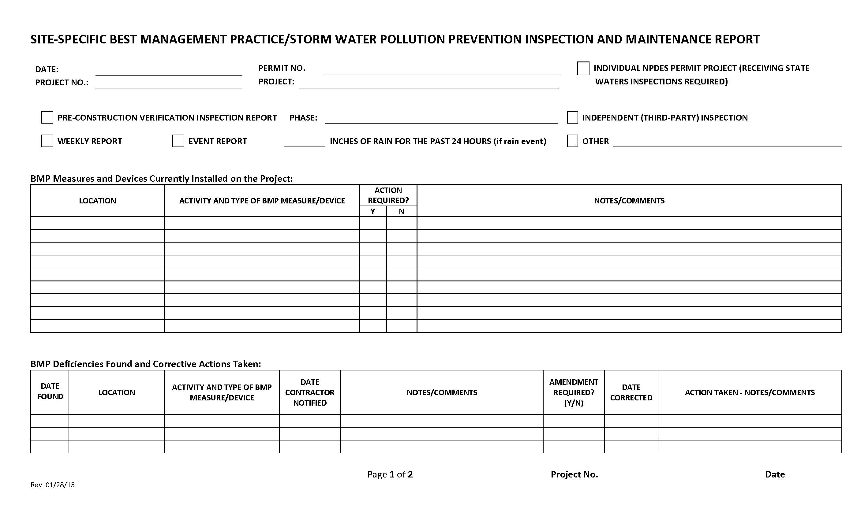

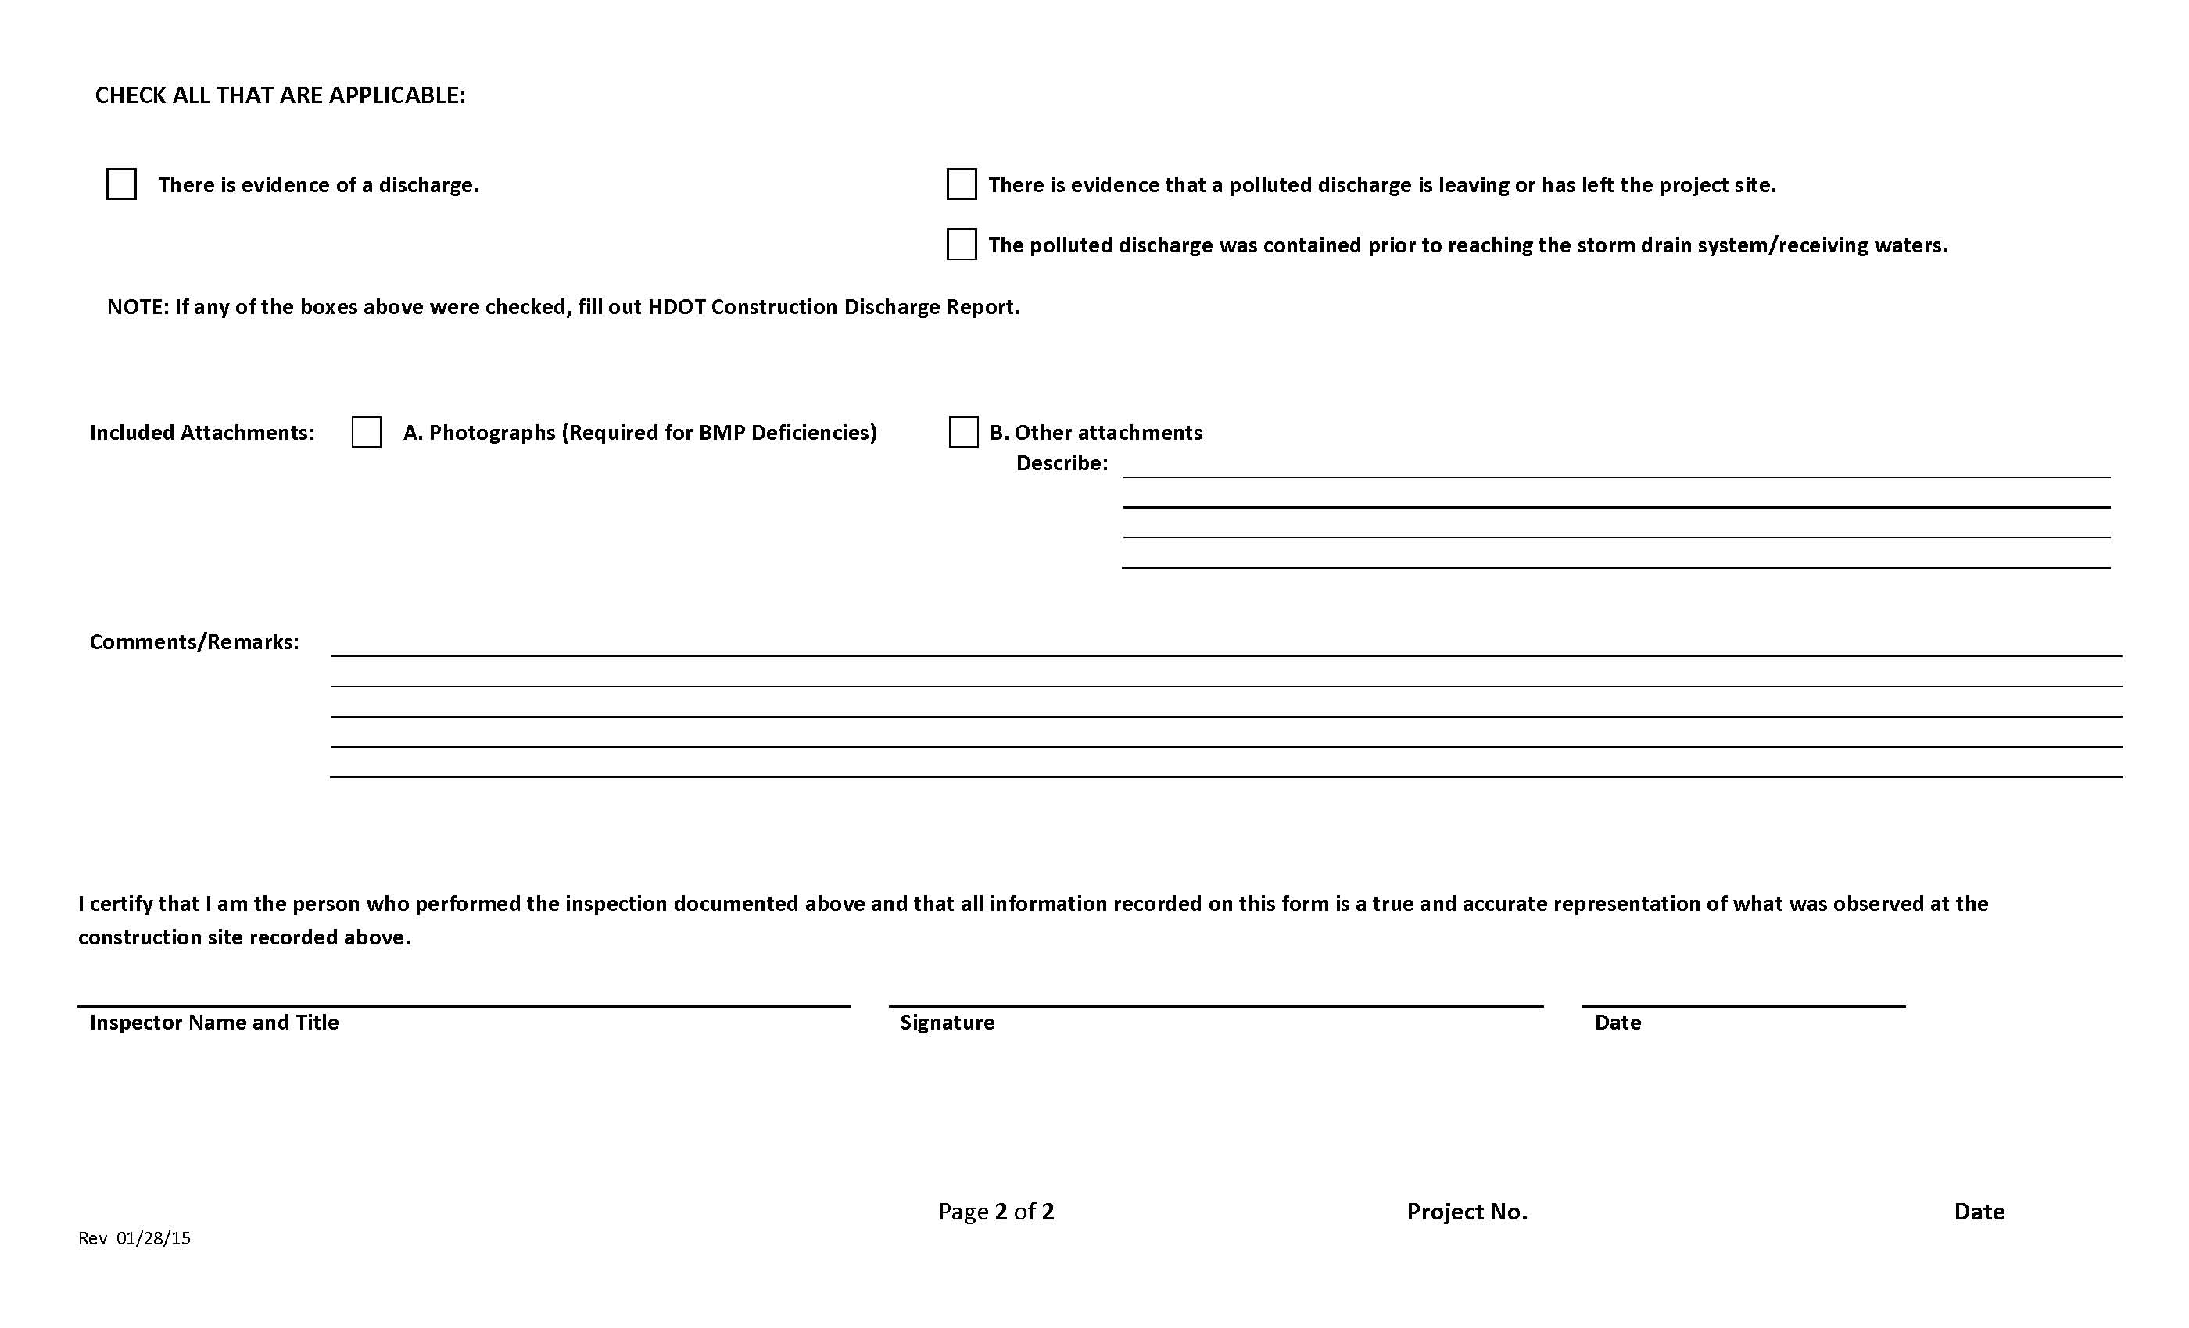

Oahu Attachment E2 – Corrective Action Reports (SWPPP Section 7.2.12) Rev. 02/25/14
Hawaii Department of Transportation Corrective Action Report

Section 10.1 “Corrective Actions” Defined
Corrective actions are actions taken in compliance with this section to:
a. Repair, modify, or replace any storm water control used at the site
b. Clean up and properly dispose of spills, releases, or other deposits
c. Remedy a permit violation

Section 10.2.1. Triggering Events
The following are triggers that require corrective action be taken (this triggering condition is to be documented within 24 hours of discovering the occurrence):
    - A required storm water control was never installed, was installed incorrectly, or not in accordance with the requirements in HAR Chapter 11-55, Sections 5 and/or 6.
- The Contractor/Engineer becomes aware that the storm water controls installed and being maintained are not effective enough for the discharge to meet applicable water quality standards or applicable requirements in HAR Chapter 11-55, Section 6.1. The Contractor shall notify the Engineer immediately. The Engineer will notify the Department of Health by the end of the next work day.
Date/time Engineer notified by Contractor
Date/time DOH notified by Engineer
- One of the prohibited discharges below is occurring or has occurred:
- Wastewater from washout of concrete
- Wastewater from washout and cleanout of stucco, paint, form release oils, curing compounds and other construction materials
- Fuels, oils, or other pollutants used in vehicle and equipment operation and maintenance
- Soaps, solvents, or detergents used in vehicle and equipment washing
- Toxic or hazardous substances from a spill or other release

Section 10.2. Requirements for Taking Corrective Actions
The Contractor shall complete corrective actions in accordance with the deadlines specified below. In all circumstances, the Contractor shall immediately take all reasonable steps to minimize or prevent the discharge of pollutants until a permanent solution is installed and made operational, including cleaning up any contaminated surfaces so that the material will not discharge in subsequent storm events. Immediately means the same day the condition is discovered, unless it is too late in the day, in which initiation of corrective action must begin on the following work day.
Following any of the above triggering events, the Contractor shall install a new or modified control and make it operational, or complete the repair, by no later than 7 calendar days from the time of discovery. If it is infeasible to complete the installation or repair within 7 calendar days, the Contractor shall document and submit to the Engineer, for his agreement, why it is infeasible to complete the installation or repair within the 7 calendar day timeframe and document a schedule for installing the storm water control(s) and making it operational as soon as practicable after the 7-day timeframe.
Date installation/repair completed or date/time prohibited discharge ceased
Reason it is infeasible to complete installation or repair within 7 calendar days and proposed schedule (if applicable)

10.4.1. Initial Report (24 Hours)
Within 24 hours of discovering the occurrence of one of the triggering conditions in HAR Chapter 11-55, Section 10.2.1. at the site, the Contractor must complete the following:
- The nature of the condition identified
- The date and time of the condition identified and how it was identified

10.4.2. Final Report (7 Days)
Within 7 calendar days of discovering the occurrence of one of the triggering conditions in HAR Chapter 11-55, Section 10.2.1. at the site, the Contractor must complete a report of the following:
- Any follow-up actions taken to review the design, installation, and maintenance of storm water controls, including the dates such actions occurred
- A summary of storm water control modifications taken or to be taken, including a schedule of activities necessary to implement changes, and the date the modifications are completed or expected to be completed
- Notice of whether SWPPP modifications are required as a result of the condition identified or corrective action

Section 10.2.2. SWPPP Modification Due to Corrective Actions
Where corrective actions result in changes to any of the storm water controls or procedures documented in the SWPPP, modify the SWPPP accordingly within 7 calendar days of completing corrective action work.
Date SWPPP modified should be indicated in the Amendment Log

Section 10.3 Corrective Actions Required by the Department of Health (DOH)
The Contractor shall comply with any corrective actions required by the department as a result of permit violations found during an inspection by DOH or EPA.
Was the Corrective Action triggered by a DOH/EPA inspection?
Yes No
Date of DOH/EPA Inspection

Section 10.4.3. Certification
The certifying person and duly authorized representative shall meet the requirements of Hawaii Administrative Rules 11-55, Appendix A, Section 15.
I certify under penalty of law that this document and all attachments were prepared under my direction or supervision in accordance with a system designed to assure that qualified personnel properly gather and evaluate the information submitted. Based on my inquiry of the person or persons who manage the system, or those persons directly responsible for gathering the information, the information submitted is, to the best of my knowledge and belief, true, accurate, and complete. I am aware that there are significant penalties for submitting false information, including the possibility of fine and imprisonment for knowing violations.

Section 10.4.4. Corrective Action Report

NOTE: Corrective Actions shall be documented in the Site-Specific Best Management Practice/Storm Water Pollution Prevention Inspection and Maintenance Report, See Attachment E1.

Oahu Attachment E3 – HDOT Highways Oahu Construction Discharge Response Flow Chart, Rev. 11/17/2015; HDOT Construction Discharge Report Form (SWPPP Section 7.2.12) Rev. 1/28/15
(See Next Pages)

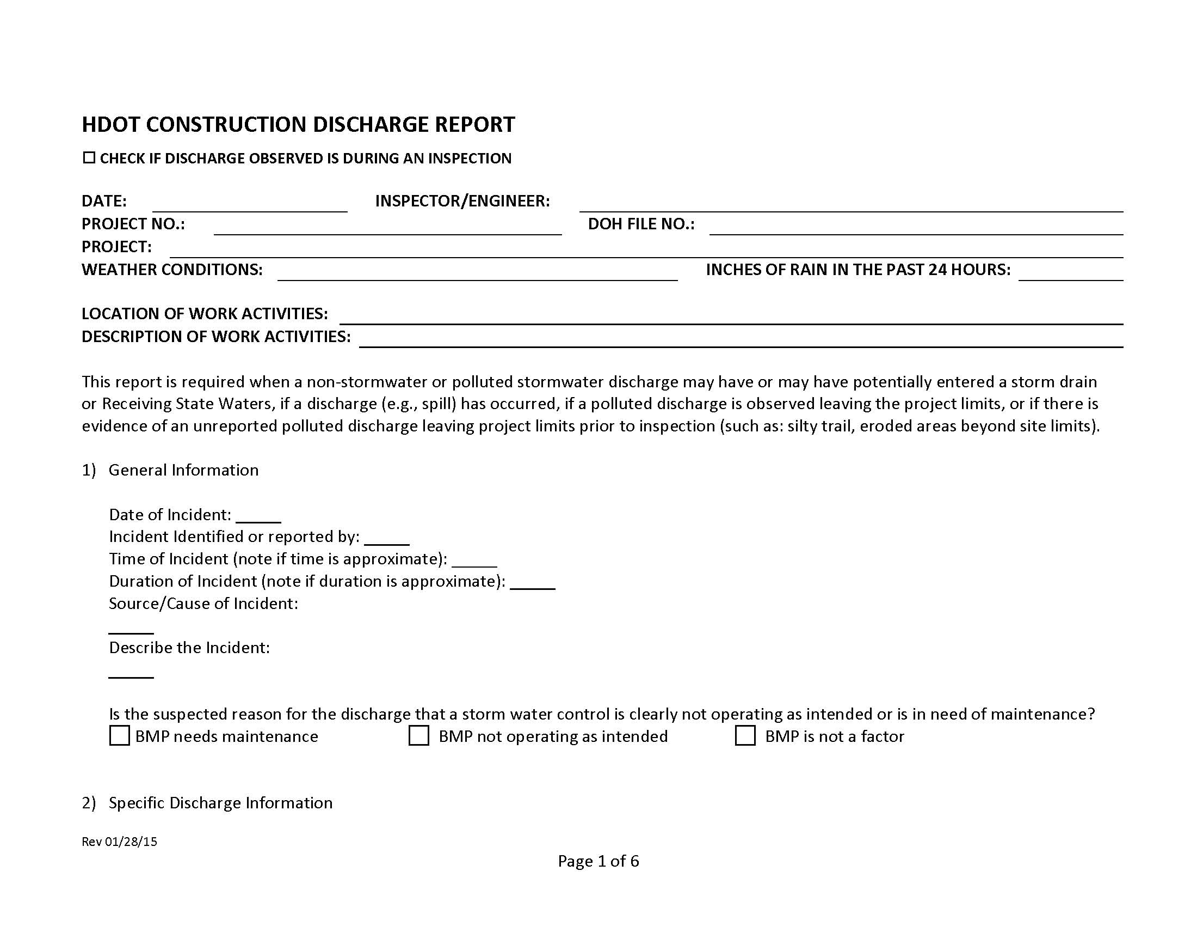
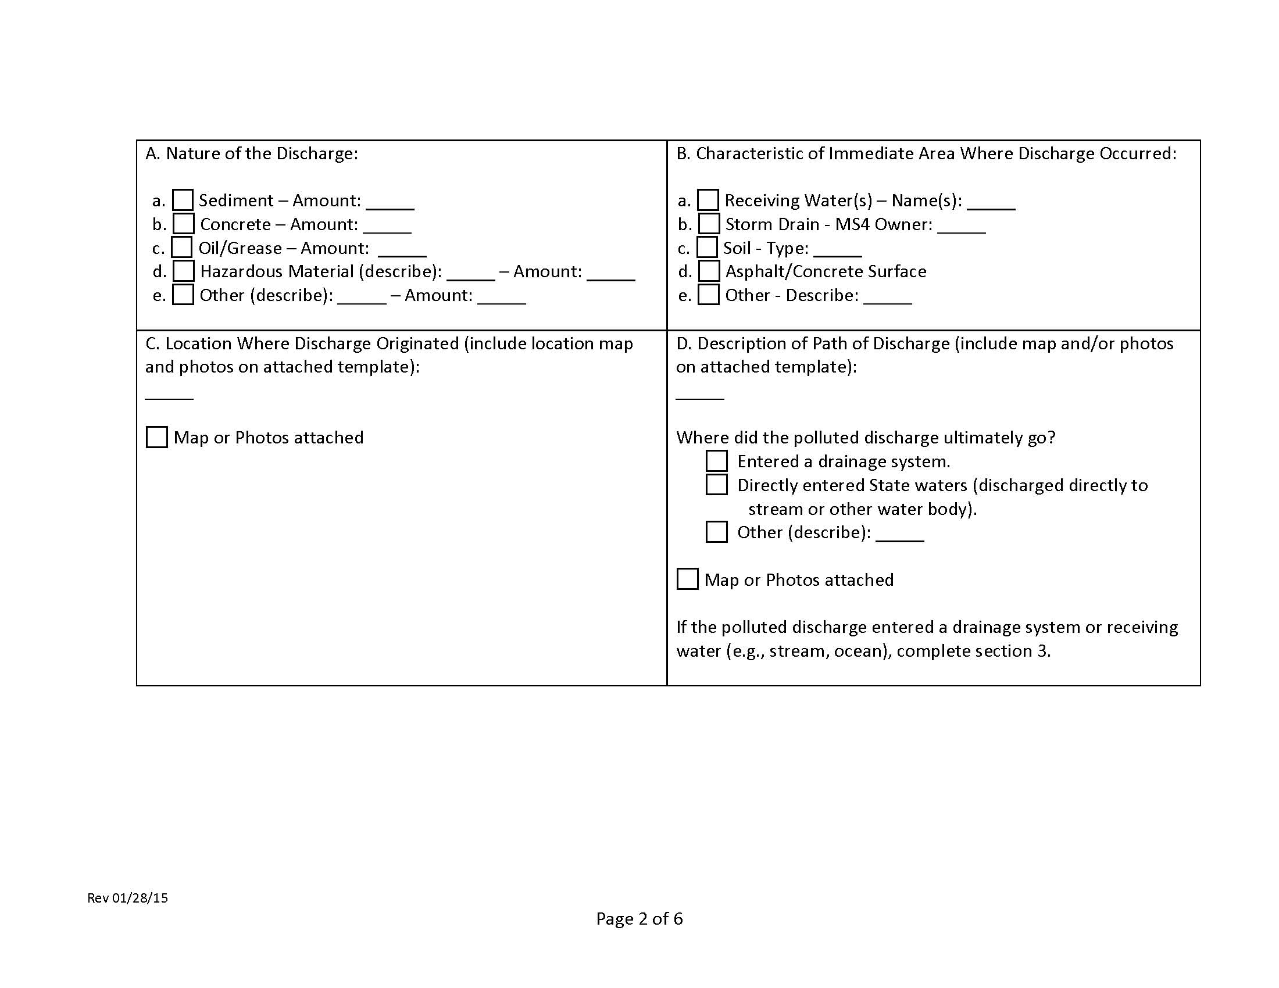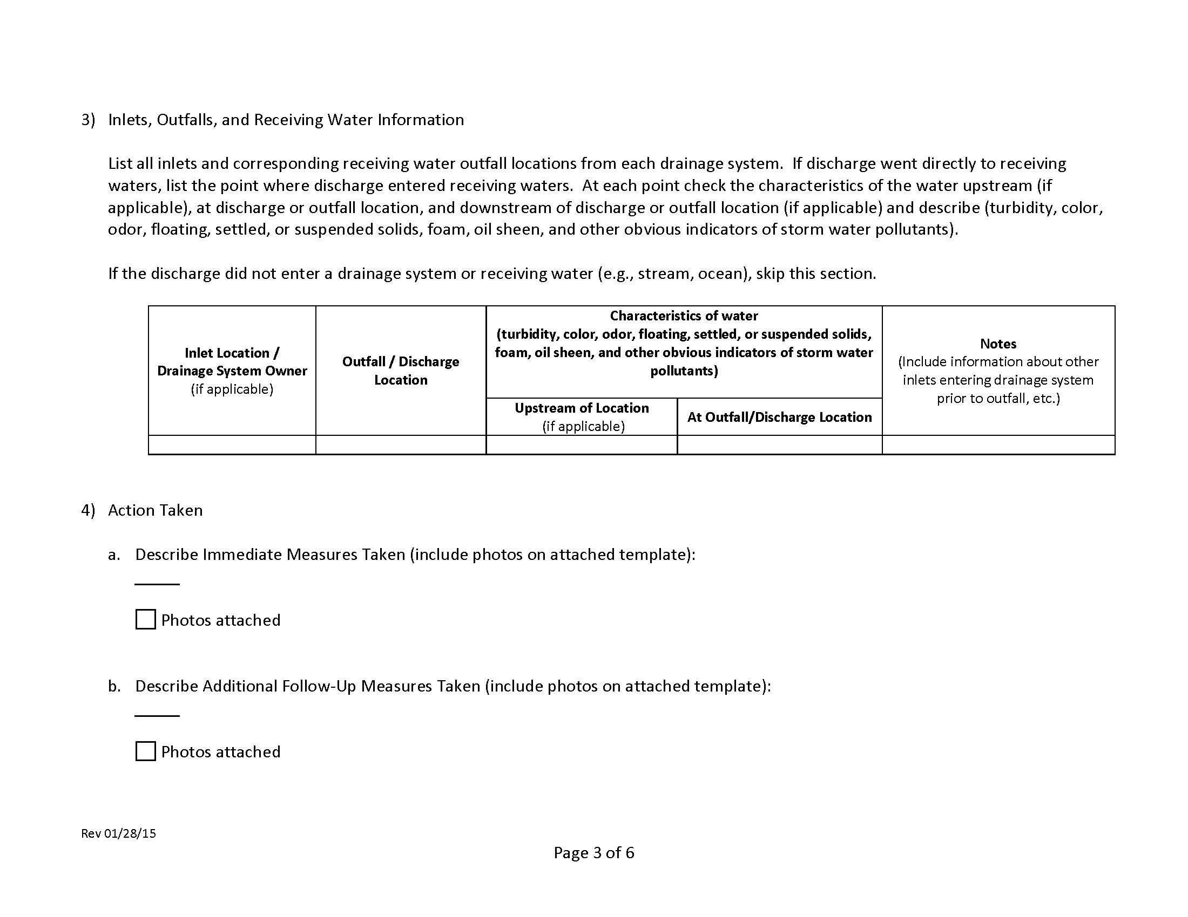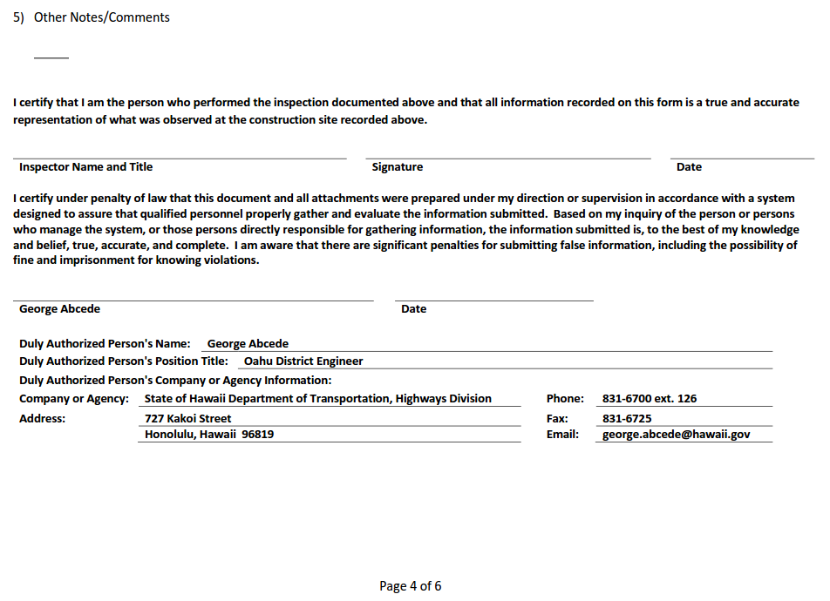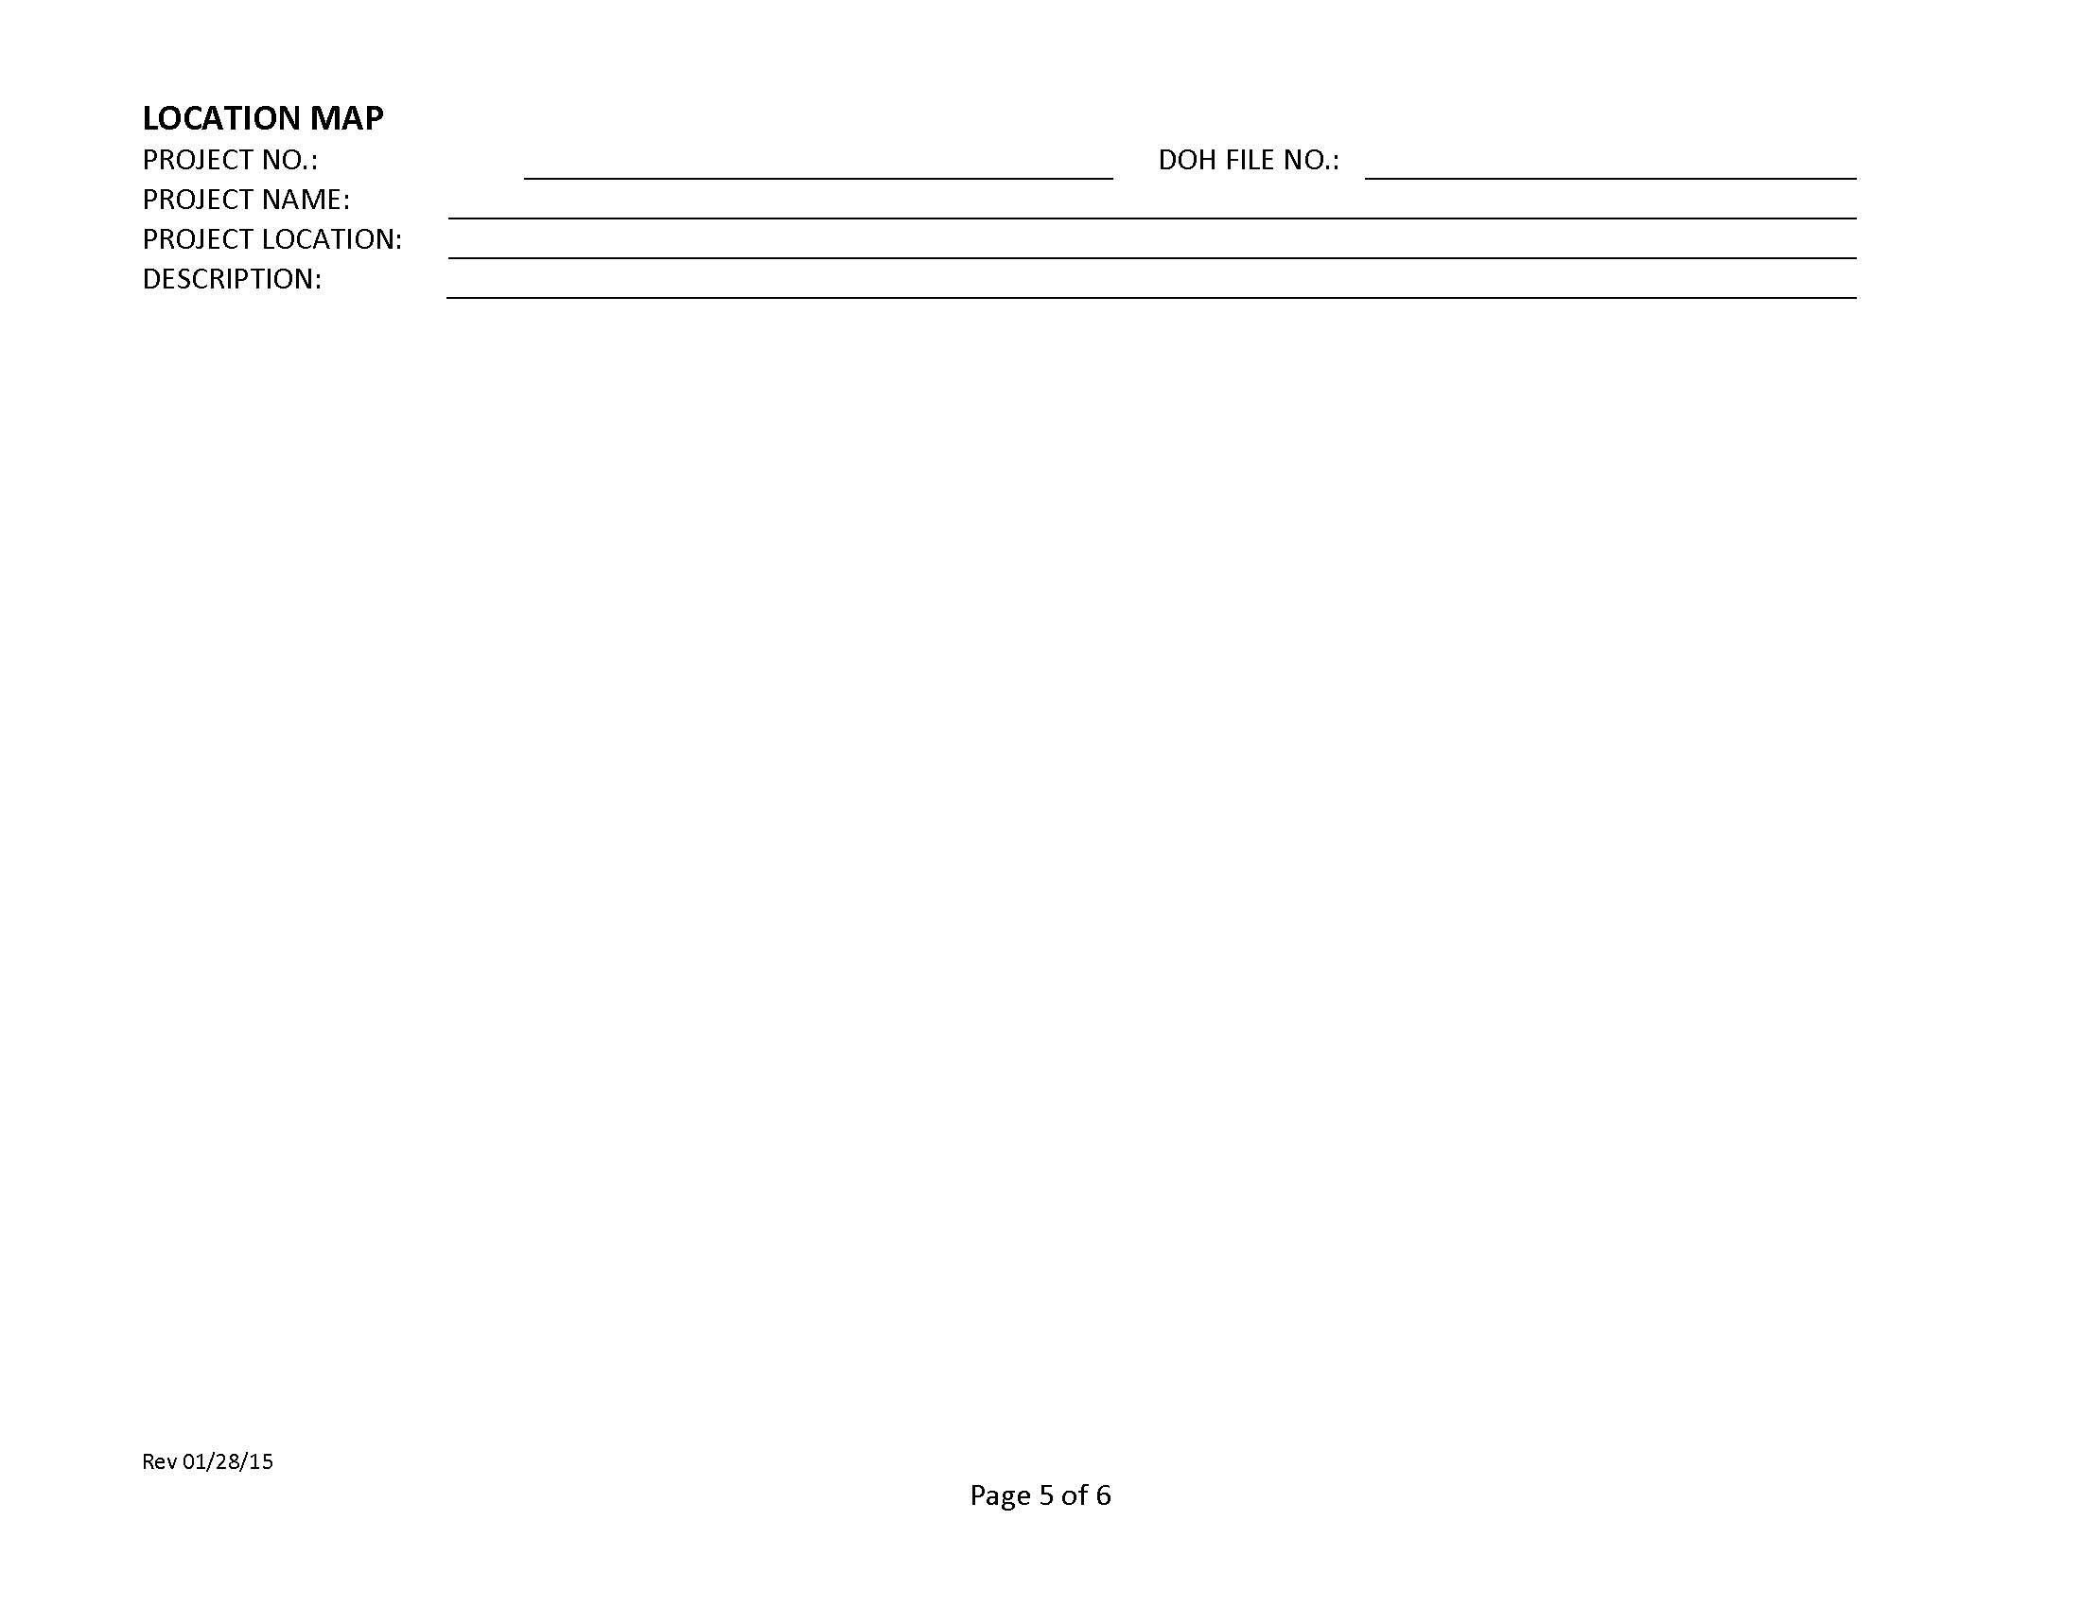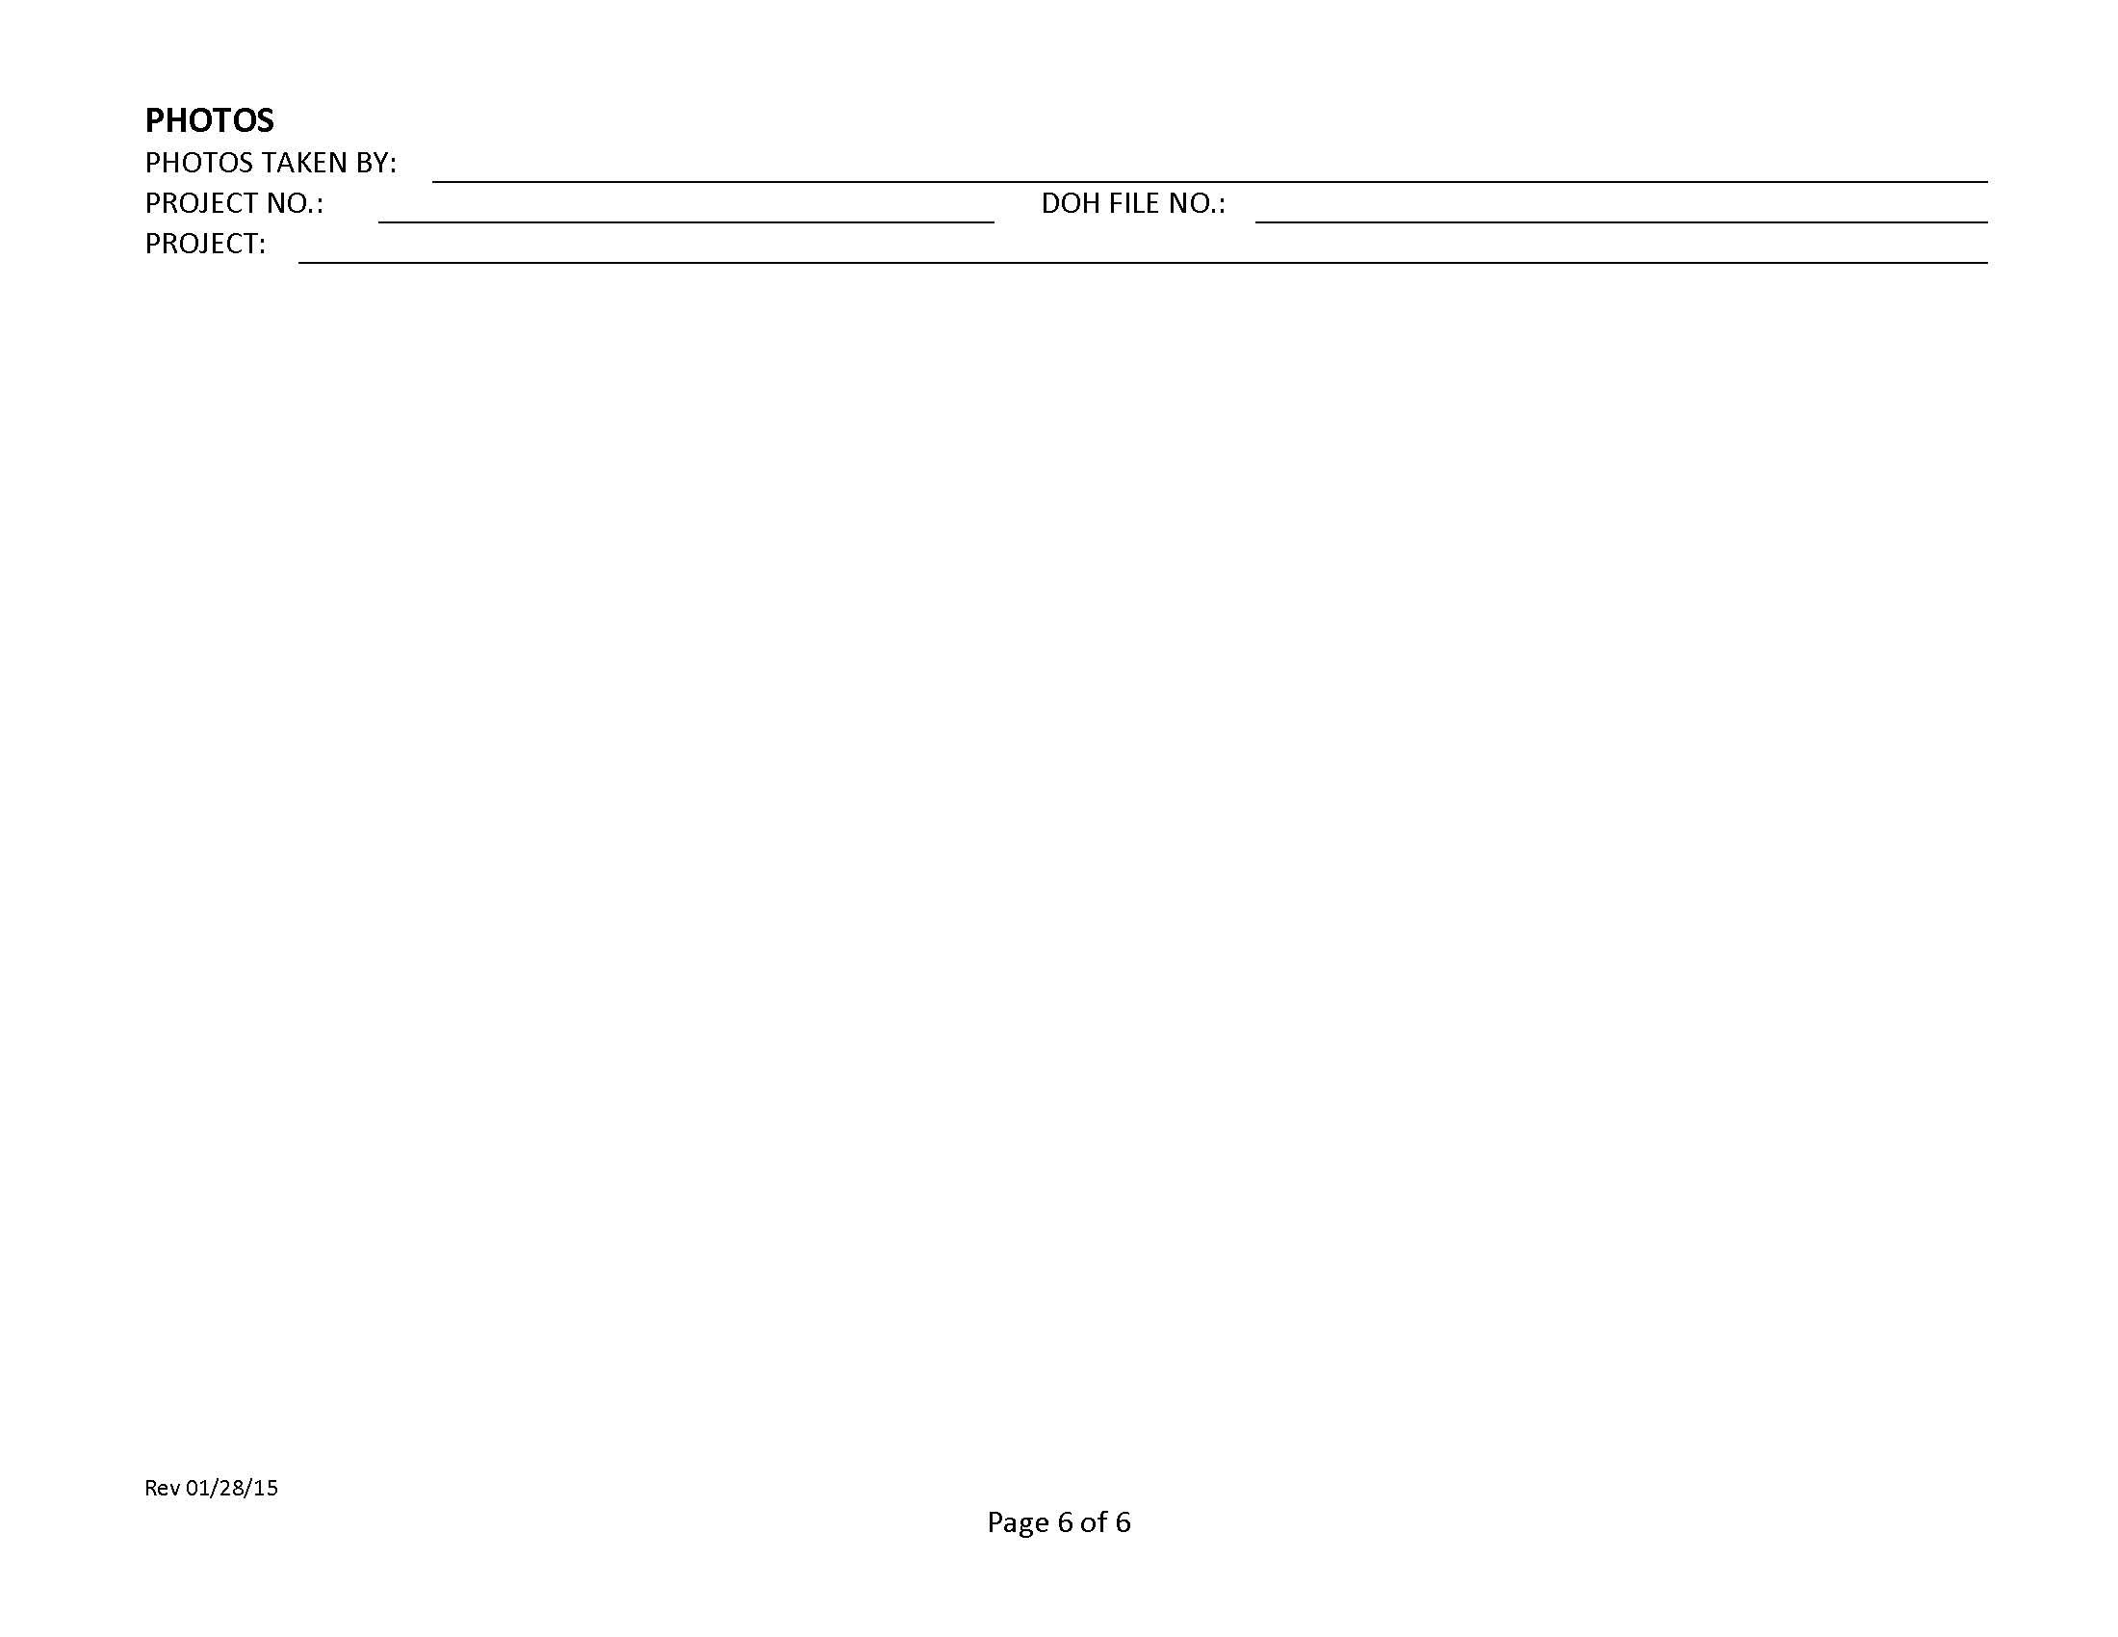

Oahu Attachment E4 – Monthly Compliance Report

Hawaii Department of Transportation Monthly Compliance Report

A Monthly Compliance Report is required to be completed within 2 working days of the end of the month. This report must be kept on-site and made available by the end of the next business day when requested by DOH. The following is required to be addressed in the Monthly Compliance Reports and include attachments as necessary.

Any instances of non-compliance or corrective actions
Changes to the information on file with DOH

If the activity is in compliance and none of the information on file with the department requires updating, or there were no incidences of non-compliance, preparation of the monthly compliance information is still required which states:
No changes, updates, or any incidences of non-compliance to report.

The certifying person and duly authorized representative shall meet the requirements of Hawaii Administrative Rules 11-55, Appendix A, Section 15. The certifying person or duly authorized representative is required to sign the Monthly Compliance Reports with the following certification statement:

I certify under penalty of law that this document and all attachments were prepared under my direction or supervision in accordance with a system designed to assure that qualified personnel properly gather and evaluate the information submitted. Based on my inquiry of the person or persons who manage the system, or those persons directly responsible for gathering the information, the information submitted is, to the best of my knowledge and belief, true, accurate, and complete. I am aware that there are significant penalties for submitting false information, including the possibility of fine and imprisonment for knowing violations.

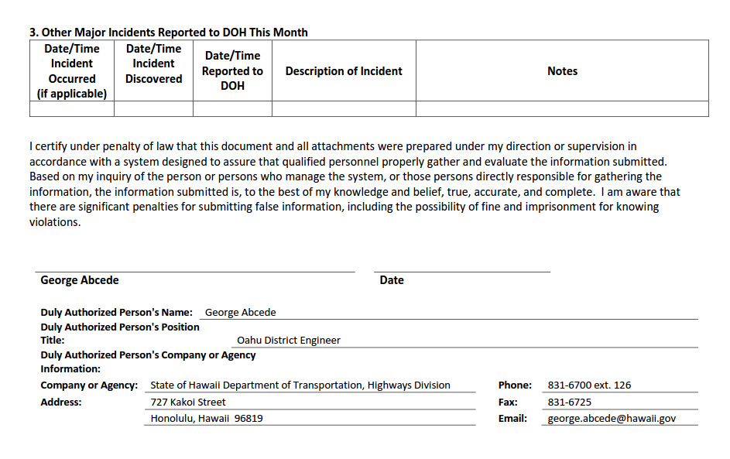

Oahu Attachment E5 – Receiving State Waters Inspection Report for Individual NPDES Permits (SWPPP Section 7.2.12) Rev. 01/28/15

Permit NO. HISXXXXXX, A. General Requirements, Item 6:

Inspect, at a minimum of once per week, the receiving state waters, storm water runoff and control measures and BMPs to detect violations of and conditions which may cause or contribute to a violation of the basic water quality criteria as specified in HAR, Chapter 11-54, Section 11-54-4 (e.g., the Permittee shall look at storm water discharges and receiving state waters for turbidity, color, floating oil and grease, floating debris and scum, materials that will settle, substances that will produce taste in the water or detectable off-flavor in fish, and inspect for items that may be toxic or harmful to human or other life).

The Receiving State Waters Inspection Report for Individual NPDES Permits shall be used to document the weekly inspections of the receiving state waters.

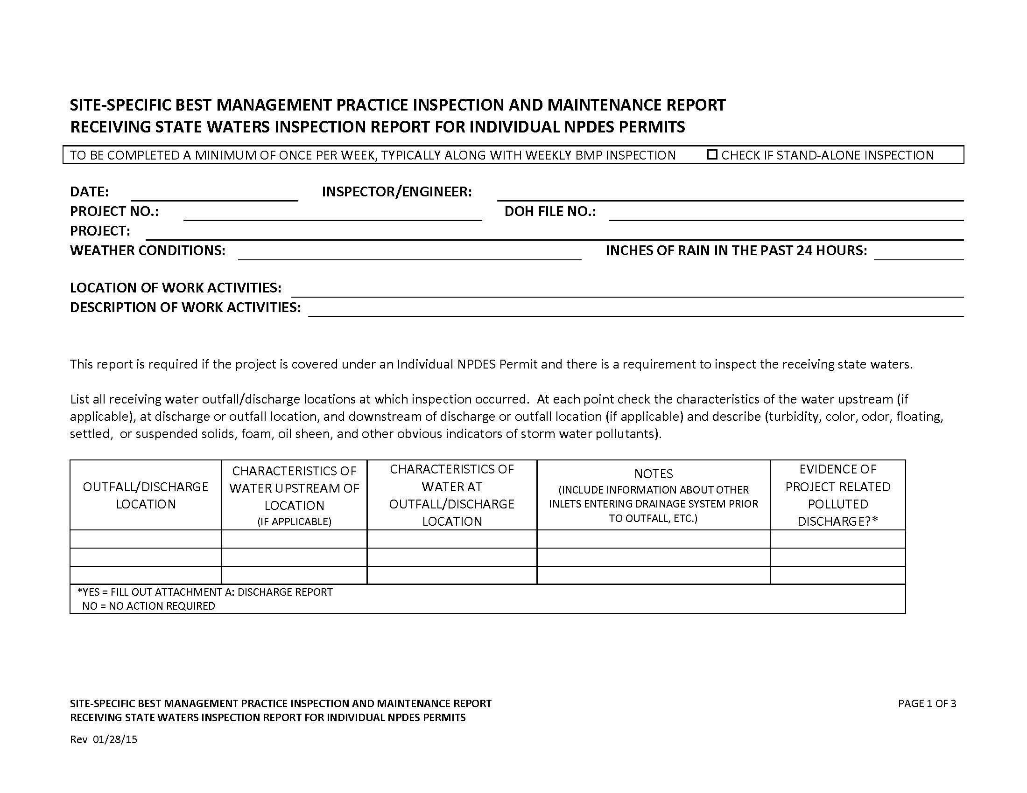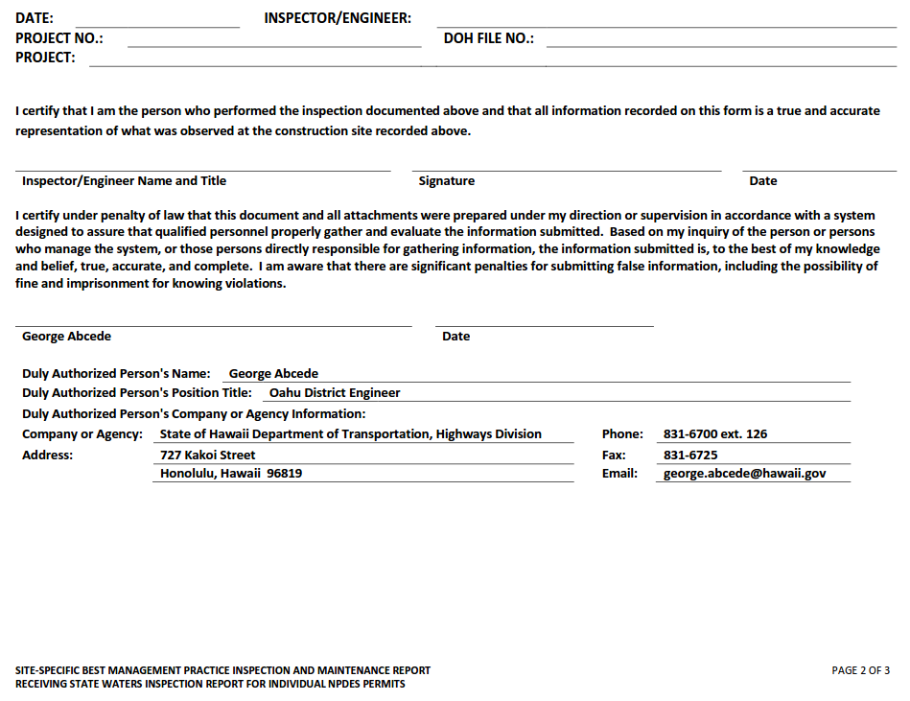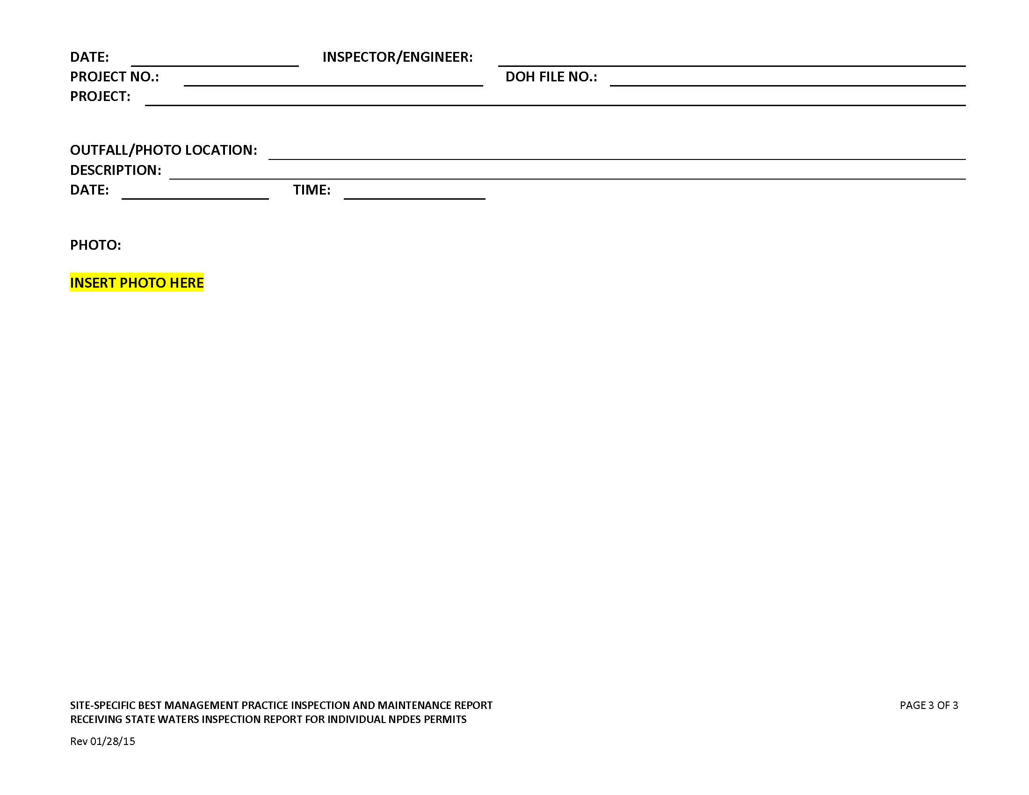

Kauai/Maui/Hawaii Attachment E1 – HDOT Inspection Report for Kauai, Maui, and Big Island

HDOT INSPECTION REPORT FORM
Date: Project/Site: Permit No.: HI
Inspector’s Name:
Inspector’s Title:
Weather:
Rain Gauge Site and Amount in Inches (If applicable) inches

The Following Areas Have been Inspected | Yes | No | N/A | Notes
9.1.5a All areas that have been cleared, graded, or excavated and that have not yet completed stabilization consistent with section 5.2
9.1.5b All storm water controls (including pollution prevention measures) installed at the site to comply with this permit
9.1.5c Material, waste, borrow, or equipment storage and maintenance areas that are covered by this permit
9.1.5d All areas where storm water typically flows within the site, including drainageways designed to divert, convey, and/or treat storm water
9.1.5e All points of discharge from the site
9.1.5f All locations where stabilization measures have been implemented

9.1.5 Were any portions of the site not inspected due to unsafe conditions? YES NO
If answering yes above, provide reasons why inspection of the site (or portions thereof) were unsafe and locations not inspected

Site Specific Best Management Practices (BMPs) Plan | Yes | No | N/A | Date Corrected | Notes
Is a copy of the Site Specific BMPs plan available at the site?
Is the Site Specific BMPs plan certified, signed, and dated?
Is the Site Specific BMPs plan current and up-to-date?
Are accompanying erosion and sediment control (ESC) drawings available at the site?
Are the Erosion and Sediment Control (ESC) drawings up-to-date?
Are all NPDES permits available at the site?
Are inspection records available at the site?

Insert or removes rows, fill in blanks to tailor to your site.

Controlling Storm Water Flowing onto and through the Project (run-on diversion, silt fence, vegetated filter strips and buffers, etc.
Best Management Practices | Location | Installed Per Specifications (Y/N) | Adequate | Needs Maintenance | N/A | Date Corrected | Notes

Soil Stabilization (topsoil management, seeding and planting, mulching, geotextiles and mats, etc.)
Best Management Practices | Location | Installed Per Specifications (Y/N) | Adequate | Needs Maintenance | N/A | Date Corrected | Notes

Slope Protection (seeding and planting; mulching; geotextiles and mats; slope roughening, terracing and rounding, etc.)
Best Management Practices | Location | Installed Per Specifications (Y/N) | Adequate | Needs Maintenance | N/A | Date Corrected | Notes

Storm Drain Inlet Protection
Best Management Practices | Location | Installed Per Specifications (Y/N) | Adequate | Needs Maintenance | N/A | Date Corrected | Notes

Perimeter Controls and Sediment Barriers (silt fence, vegetated filer strips and buffers, etc.)
Best Management Practices | Location | Installed Per Specifications (Y/N) | Adequate | Needs Maintenance | N/A | Date Corrected | Notes

Sediment Basins and Detention Ponds (sediment traps, sediment basins, etc.)
Best Management Practices | Location | Installed Per Specifications (Y/N) | Adequate | Needs Maintenance | N/A | Date Corrected | Notes

Stabilized Ingress/Egress Structures
Best Management Practices | Location | Installed Per Specifications (Y/N) | Adequate | Needs Maintenance | N/A | Date Corrected | Notes

Additional Erosion and Sediment Control BMPs
Best Management Practices | Location | Installed Per Specifications (Y/N) | Adequate | Needs Maintenance | N/A | Date Corrected | Notes

Material Handling and Waste Management (hazardous waste management, concrete waste management, etc.)\
Best Management Practices | Location | Installed Per Specifications (Y/N) | Adequate | Needs Maintenance | N/A | Date Corrected | Notes
Material Storage
Spill Prevention/Control

Baseyard Staging Areas
Best Management Practices | Location | Installed Per Specifications (Y/N) | Adequate | Needs Maintenance | N/A | Date Corrected | Notes

Washout Areas
Best Management Practices | Location | Installed Per Specifications (Y/N) | Adequate | Needs Maintenance | N/A | Date Corrected | Notes
Concrete Washout/Waste
Paint Washout/Waste

Proper Equipment/Vehicle Fueling and Maintenance Practices
Best Management Practices | Location | Installed Per Specifications (Y/N) | Adequate | Needs Maintenance | N/A | Date Corrected | Notes
Equipment/Vehicle Fueling
Equipment/Vehicle Cleaning
Equipment/Vehicle Maintenance

Additional Non-Erosion or Sediment Control BMPs
Best Management Practices | Location | Installed Per Specifications (Y/N) | Adequate | Needs Maintenance | N/A | Date Corrected | Notes

Post Construction BMPs (flared culvert end sections, rip-rap and gabion inflow protection, outlet protection and velocity dissipation devices, etc.)
Best Management Practices | Location | Installed Per Specifications (Y/N) | Adequate | Needs Maintenance | N/A | Date Corrected | Notes

Other
Best Management Practices | Location | Installed Per Specifications (Y/N) | Adequate | Needs Maintenance | N/A | Date Corrected | Notes
Sawcutting
Dust Control
Dewatering

Insert or removes rows, fill in blanks to tailor to your site.
Site Conditions | Yes | No | N/A | Notes and Corrective Actions
9.1.6.1 Do all erosion and sediment controls and pollution prevention controls installed, appear to be operational, and working as intended to minimize pollutants discharges?
9.1.6.1 Any controls need to be replaced, repaired, or maintained in accordance with HAR Ch. 11-55 sections 5.1.1.4 and 5.3.2?
9.1.6.2 Any conditions present that could lead to spills, leaks, or other accumulations of pollutants on the site?
9.1.6.3 Any locations where new or modified storm water controls are necessary to meet the requirements of HAR Ch. 11-55 sections 5 and/or 6?
9.1.6.5 Any incidents of noncompliance observed?
Are off-site flows entering the construction site?
9.1.6.4 At points of discharge are there signs of visible erosion and sedimentation that have occurred and are attributable to the discharge?
9.1.6.4 On the banks of any state waters flowing within the property boundaries are there signs of visible erosion and sedimentation that have occurred and are attributable to the discharge?
9.1.6.4 On the banks of any state waters flowing adjacent to the property are there signs of visible erosion and sedimentation that have occurred and are attributable to the discharge?
Are construction materials/debris/trash/soil stored or disposed of properly at the site?
Is there vehicle tracking from the site to receiving streets?
Do locations exist where additional or revised BMPs are needed?
Do locations exist where BMPs may no longer be necessary and may be removed?
Does your site evaluation indicate a need to update or revise the current Site Specific BMPs plan and/or accompanying erosion and sediment control drawings?

9.1.6.6 Discharges Observed During Inspection
Is a discharge occurring during the inspection? YES NO
If answering YES above answer the following:
9.1.6.6a Identify all points of the property from which there is a discharge
9.1 Is there a potential for downstream erosion? YES NO
If YES continue to the next question. If NO go to 9.1.6.6b and inspect at the Receiving Water.
9.1 Does the discharge enter an MS4 or separate drainage system prior to the receiving water? YES NO
If YES go to 9.1.6.6b and inspect Where it Enters the Drainage System. If NO continue to the next question.
9.1 Does the effluent comingle with offsite water or pollutant sources prior to discharging to the receiving water? YES NO
If YES go to 9.1.6.6b and inspect at a Location Representative of the Discharge Quality Prior to Comingling.
If NO go to 9.1.6.6b and inspect at the Receiving Water if safe to do so. If unsafe, document in section 9.15 above.

9.1.6.6b What color is the discharge?

9.1.6.6b Is there an odor? Describe if possible.

9.1.6.6b Are there floating, settled, or suspended solids? If so, describe?

9.1.6.6b Is there foam?

9.1.6.6b Does the discharge contain an oil sheen?

9.1.6.6b Are there any other obvious indicators of storm water pollutants in the discharge?

9.1.6.6c Is the suspected reason for the discharge that a storm water control is clearly not operating as intended or is in need of maintenance?

Photos
Photos taken during the BMP inspection documented above are:
Attached
Inserted
Not taken, attached, or inserted.
(Insert photos in this section if you so choose.)

I certify that I am the person who performed the inspection documented above and that all information recorded on this form is a true and accurate representation of what was observed at the construction site recorded above. Any photographs attached that were taken during the inspection are a true, accurate, and unaltered representation of what was observed during the inspection documented above.

Inspector’s Printed Name: Title:

Inspector’s Signature: Date of Inspection:

Inspector’s Printed Name: Title:

Inspector’s Signature: Date of Inspection:

The certifying person and duly authorized representative shall meet the requirements of Hawaii Administrative Rules 11-55, Appendix A, Section 15.

I certify under penalty of law that this document and all attachments were prepared under my direction or supervision in accordance with a system designed to assure that qualified personnel properly gather and evaluate the information submitted. Based on my inquiry of the person or persons who manage the system, or those persons directly responsible for gathering the information, the information submitted is, to the best of my knowledge and belief, true, accurate, and complete. I am aware that there are significant penalties for submitting false information, including the possibility of fine and imprisonment for knowing violations.

Signature: Date:
Duly Authorized Person’s Name: Lawrence J. Dill
Duly Authorized Person’s Position Title: Kauai District Engineer
Duly Authorized Person’s Company or Agency: Department of Transportation
Department: Department of Transportation
Division: Department of Transportation, Highways Division
Phone Number: (808) 241-3000 Fax No.: (808) 241-3011
Person Email: lawrence.j.dill@hawaii.gov

Attachment F – Spill Prevention and Response Procedures (SWPPP Section 7.2.11.1)
Spill Prevention and Control Plan (SM-10)

Description Practices and procedures to reduce or prevent leaks or spills of fuels, oil, and other chemicals which may be discharged into the storm drain system or adjacent water bodies.

Applications Construction projects involving the storage of chemicals or hazardous
substances.

Installation and General Requirements include the following:
Implementation • Store hazardous materials and wastes in covered containers and
Requirements protect containers from vandalism;
• Maintain an ample supply of cleanup materials for spills shall be
readily accessible;
• Train employees on proper spill prevention and cleanup; and
• Review spill response requirements at all applicable work sites.
Cleanup Requirements include the following:
• Immediately clean up leaks and spills;
• Use minimal water to clean up spills on paved surfaces. For small
spills, use a rag. For general cleanup, use a damp mop. For larger
spills, use absorbent materials. Properly dispose of materials used
to clean up hazardous materials;
• Do not hose down or bury spills; and
• Eliminate the source of the spill to prevent a discharge or continuation of an ongoing discharge.

Reporting includes the following:
• Report significant spills to the U.S. coast Guard, DOH Clean Water Branch, Hawaii State Office of Hazard Evaluation and Emergency Response, and City and County of Honolulu agencies, such as the Fire Department and
• Per federal regulations, report significant spills of oil onto an
adjoining shoreline or into a water body to the National Response
Center at 800-424-8802 (24 hour).

Vehicle and equipment maintenance activities requirements include the
following:
• Use a designated area and/or secondary containment for on-site
repair or maintenance activities. These areas shall be located away
from drainage courses;
• Complete regular inspections of on-site vehicles and equipment,
including delivery trucks and employees’ vehicles, for leaks. Do not
allow vehicles or equipment with leaks on-site. Provide Vehicle and Equipment Maintenance BMPs in SM-12 if repair must be made on site.
• Secondary containment devices such as drop cloths and drain pans
shall be used to catch leaks or spills while removing or changing
fluids from vehicles or equipment;
• Place drip pans or absorbent materials under paving equipment not
in use;
• Use absorbent materials on small spills. Do not hose down or
bury spills. Remove and properly dispose of cleanup materials;
• Immediately transfer used fluids to the appropriate waste or
recycling containers. Avoid leaving full drip pans and open
containers on-site;
• Drain excess oil from oil filters prior to disposal by placing filter in a
funnel over a waste oil recycling drum. Recycle oil filters if this
service is available or dispose in accordance with Federal, State, and Local requirements;
Installation and • Store all cracked batteries in a non-leaking secondary container with cover
Implementation even if the acid appears to have drained out. Handle dropped
Requirements batteries as cracked batteries until assured it is not leaking.
(Continued) • Dispose of or recycle oil in accordance with Federal, State, and Local requirements. Store in water-tight container and provide cover to prevent containers from coming into contact with rainwater or secondary containment.

Vehicle and equipment fueling activities requirements include the
following:
• Use designated areas for required on-site fueling. Fueling areas
shall be located away from drainage courses;
• Avoid “topping off” of fuel tanks; and
• Use secondary containment devices such as drain pans to catch
spills or leaks while fueling.

Limitations Use of a private spill cleanup company may be necessary.

Inspections and • Update spill prevention and control plans and stock necessary
Maintenance cleanup materials as the chemicals used or stored on-site change.
• Ample supplies of materials for spill control and cleanup shall be
located on-site near maintenance and material storage or unloading
areas.

Emergency Spill Response Plan

Procedures for expeditiously stopping, containing, and cleaning up spills, leaks, and other releases (7.2.11.1a).

Spill Coordinator
The Contractor shall appoint a Primary and Secondary Emergency Spill Response Coordinator who will be responsible for the reporting of spills, coordinating contractor personnel for spill cleanup, subsequent site investigations, and associated reports. In the event of a spill, the Emergency Spill Response Coordinator will be responsible for determining the extent of the containment/isolation area and cleanup methods. Include Names, positions, and emergency contact information.
The Contractor shall make contact with a Spill Cleanup Emergency Response Contractor prior to start of construction to provide sufficient information for the spill contractor to be prepared should they receive a call in the event of an emergency.

Immediate Response
All spills regardless of size must be reported to the Emergency Spill Response Coordinator and the (HDOT Construction Resident Engineer/Project Engineer/Construction Inspector). The person observing the incident will take the following actions:
• Assess the safety of the situation (including the risk to the surrounding public).
• Alert nearby personnel and secure the immediate area for safety.

If the person is aware the chemical spilled is not toxic or a known petroleum product do the following:
• Make every effort to remove potential ignition sources and stop the source of the spill.
• Clean the spill using absorbent materials available on-site. Do not hose down or bury spills. Remove and properly dispose of cleanup materials.
• Promptly notify the Emergency Spill Response Coordinator. Report name, the spill location, material spilled, and the extent of the incident.

Upon learning of the spill, the Emergency Spill Response Coordinator will implement the following measures:
• Assess the safety of the situation (including the risk to the surrounding public).
• If the source of the spill is toxic or unknown, immediately notify the Fire Department and ask for assistance from the HAZMAT team.
• Secure the area by stopping traffic if necessary and install barricades or safety fencing around the area.
•If safe to do so, prevent hazardous material from entering the stormwater or sewer system or any waterbodies by covering/blocking any drains in the spill area, and providing containment BMPs to either prevent stormwater from contacting hazardous material or contain commingled stormwater.
•If safe to do so, absorbent materials will be applied to the spill area. Contaminated soils and vegetation will be excavated and temporarily placed on and covered by plastic sheeting or in an appropriate container or surrounded by impermeable lined berms in a containment area a minimum of 100 feet away from any wetland or waterbody, until proper disposal is arranged.
• Notify appropriate agencies as required by Federal, State, and local regulations.
•For petroleum spills, provide notification if the release meets any of conditions the below:
  - Greater than 25 gallons
  - Not cleaned within 72 hours
  - Enters a storm drainage system or state waters
• Arrange for proper disposal (including contaminated personal protective equipment and/or cleanup supplies) in accordance with Federal, State, and local regulations and Manufacturer’s instructions if known.
• If a spill is beyond the scope of on-site equipment and personnel, contact the Spill Cleanup Emergency Response Contractor to further contain and clean up the spill.
• Notify the (HDOT Construction Resident Engineer/Project Engineer/Construction Inspector).

Contents of the Spill kits shall be determined by the Contractor based on the anticipated type and quantity of hazardous material to be stored/used on-site. The kit should contain at minimum:
•55 gallon drum with lid
•absorbent pads (50)
•absorbent socks (12)
•absorbent pillows (5)
•1 pair goggles or faceshield
•1 pair elbow length gloves
•1 disposable apron
•disposable bags with ties (3)
•Include additional materials such as Absorbent Skimmers or Booms for work adjacent or over State Waters as needed.
•Include additional materials as necessary to secure the spill area.

Procedures for notification of appropriate facility personnel, emergency response agencies, and regulatory agencies where a leak, spill, or other release containing a hazardous substance or oil in an amount equal to or in excess of a reportable quantity consistent with HAR 11-55 subsection 5.3.4. and established under either 40 CFR Part 110, 40 CFR Part 117, or 40 CFR Part 302, occurs during a 24-hour period (7.2.11.1.b).
• Contact information must be in locations that are readily accessible and available.
• The Contractor shall take all reasonable measures to protect human health and the environment.
• For emergencies or life-threatening situations, call 911 first.

• Notify responsible parties listed below as required and immediately notify DOH Clean Water Branch and the National Response Center of the incident. The notification shall also include the identity of the pollutant sources and the implemented control or mitigation measures. Notify other agencies as required by Federal/State/Local laws. List additional agencies or personnel below as required.

1. Owner Contact/Emergency Contact Number: (HDOT Construction Resident Engineer/Project Engineer/Construction Inspector)

2. Authorized Representative/ Emergency Contact Number: (HDOT District Engineer or designated representative who can contact Authorized Representative)

3. Contractor/ Emergency Contact Number: (Contractor Emergency Contact)

4. Department of Health
Clean Water Branch (During regular working hours): ……………………….808-586-4309
Hawaii State Hospital Operator (After hours):……………………………….. 808-247-2191
AND E-mail Clean Water Branch via email at cleanwaterbranch@doh.hawaii.gov

5. Hawaii Hazard Evaluation and Emergency Response (HEER) ………….808-586-4249
(After Hours) ……………………...808-247-2191
AND

Appropriate Local Emergency Planning Committee (LEPC)

For projects on Hawaii Island
Henry Silva, Hawaii County LEPC……………….………….808-936-0858

For projects on Oahu
Leland Nakai Department of Emergency Management……808-723-8958
LEPC……………………………………………….….808-723-8960
(After Hours)………………………………………….911

For projects on Kauai
Clifford Ikeda, Kauai Civil Defense……..…………..……….808-241-1800
(After Hours)………………………………………….808-241-6711

For projects in Maui County
Scott Kekuewa, Maui Fire Department…………………..….808-270-7911
(After Hours)………………………………………….911

6. National Response Center (NRC)…………………………………………..(800)424-8802
7. Coast Guard Operations Center, Honolulu (working hours) ……………. 808-522-8246
(After hours)…………………808-247-2191

8. County Fire Department/Police……………………………………………… 911
9. HDOT Tunnels Emergency Contact Number (After Hours)……………….808-485-6200
10. Contractor’s Spill Cleanup Emergency Response Contractor…………….xxx-xxx-xxxx

• If required, fill in and follow the requirements of the HDOT Corrective Action Report.

Attachment G – Waste Management Procedures (SWPPP Section 7.2.11.2)
Waste Management Procedures

The Contractor shall submit the DOH “Solid Waste Disclosure Form for Construction Sites” to the Engineer within 30 calendar days of contract execution. The form can be downloaded at: http://health.hawaii.gov/shwb/files/2013/06/swdiscformnov2008.pdf

Provide a copy of all the disposal receipts from the facility permitted by the Department of Health to receive solid waste to the Engineer monthly, this should also include documentation from any intermediary facility where solid waste is handled or processed, or as directed by the Engineer.

Solid Waste Management (SM-6)

Description Practices and procedures to prevent or reduce the discharge of
pollutants from construction site wastes to the drainage system or
adjacent water bodies.
Applications Construction projects generating non-hazardous solid wastes from
construction and demolition (C&D) activities. These wastes include
C&D wastes, inert fill material, and recycle/reuse material.
C&D wastes include materials originating from the demolition of roads,
buildings, or other structures. Materials generated from these
activities include concrete, brick, bituminous concrete, wood, masonry,
composition roofing, roofing paper, steel, plaster, and minor amounts
of metals.
Inert fill materials are wastes that are not contaminated with hazardous
materials such as asbestos or lead-based paint. Inert fill materials do
not decompose or produce leachate or other products harmful to the
environment. Inert fill materials include earth, soil, rock, cured asphalt,
brick, and clean concrete (no exposed steel-reinforcing rod) with no
dimension greater than eight inches.
Recycle/reuse materials include but are not limited to: asphalt
pavement, cardboard, concrete aggregate (no LBP, asbestos-free),
electronic equipment, excavated rock, soil (uncontaminated), Freon
from appliances, glass, green waste, metals, ferrous/non-ferrous, used
tires, wood and lumbers, furniture, etc.

Installation and • Separate contaminated clean up materials from C&D wastes.
Implementation Contamination may be from hazardous substances, friable
Requirements asbestos, waste paint, solvents, sealers, or adhesives. (See Section SM-9 Hazardous Waste Management)
• Inert fill material shall not contain vegetation, organic material, or
other solid waste.
• Inert fill materials shall not be mixed with other C&D waste.
• Provide waste containers of sufficient size and number to contain construction and domestic waste. Dumpsters should be securely lidded. Roll off containers
should have a cover to keep rain out or loss of waste during windy conditions. Waste containers shall meet all local and State solid waste management regulations
• Clean up and dispose of waste in designated waste containers.
• The Contractor's supervisory personnel shall be instructed regarding the correct practices for waste disposal. Post notices stating these practices in the office trailer and the Contractor shall be responsible for seeing that these practices are followed.

Limitations None

Inspections and • Inspect construction waste and recycling areas regularly.
Maintenance • Schedule solid waste collection regularly. Empty waste containers weekly or when they are two-thirds full, whichever is sooner.
• Schedule recycling activities based on construction/demolition
phases.
• Do not allow containers to overflow and clean up immediately if they do.

Sanitary/Septic Waste Management (SM-7)

Description Practices and procedures to reduce or prevent the discharge of sanitary wastes from construction sites into the storm drain system or
adjacent water bodies.
Applications Construction sites with temporary or portable sanitary/septic
waste systems.
Installation and • Locate sanitary facilities in a convenient place away from drainage
Implementation facilities and State Waters.
Requirements • Untreated wastewater shall not be discharged into the drainage system, State waters, to the ground or buried.
• Position sanitary facilities where they are secure and will not be knocked down.
• Comply with the State of Hawaii, Department of Health
requirements when using an on-site disposal system such as a
septic system.
• Avoid illicit discharges by properly connecting temporary sanitary
facilities to the sanitary sewer system.
• Sanitary/septic systems discharging to the sanitary sewer shall
comply with the local wastewater treatment plant requirements.
• A licensed service provider shall maintain sanitary/septic facilities
in good working order.
• Schedule regular waste collection by a licensed transporter at least once a week or as required.

Limitations None
Inspections and • Inspect and maintain facilities regularly.
Maintenance • Schedule regular waste collection.
• Prevent illicit discharges.

Hazardous Waste Management (SM-9)

Description Practices and procedures to prevent the discharge of hazardous waste to the land, storm drain system, sewer system, or adjacent water bodies.

Applications Handling procedures on construction sites involving one of the following
hazardous wastes:
• Paints and solvents;
• Petroleum products such as oils, fuels, and grease;
• Herbicides;
• Acids for cleaning masonry;
• Concrete curing and repair compounds; and
• Contaminated waste material.

Hazardous waste management shall also be implemented for wastes
from existing structures including:
• Sandblasted material such as grit or chips containing lead,
cadmium, or chromium-based paints;
• Asbestos; and
• Polychlorinated Biphenyls (PCBs). Older transformers are a
common source of PCBs.
Installation and Recognize potentially hazardous waste by implementing the following:
Implementation • Review product label and shipping papers;
Requirements • Identify key words such as flammable or ignitable (able to catch
fire); carcinogenic (causes cancer); toxic or poisonous (injures or
harms people or animals); and hazardous, danger, caustic or
corrosive (burns through chemical action). Hawaii
Administrative Rules (HAR) Title 11, Chapter 261 includes a list
of hazardous waste and criteria;
• Review safety data sheets (SDS), formerly material safety data sheets (MSDS) from the manufacturer and supplier of the product; and
• Contact DOH, Hazardous Waste Program Office at 586-4226 for
additional questions and information.

Material use practices and procedures for hazardous waste
management include the following:
• Dispose container only after all of the product has been used;
• Keep the original product label on the container since it includes
important safety and disposal information;
• Restrict amount of herbicide prepared to quantity necessary for
the current application. Comply with the recommended usage
instructions. Do not apply herbicides during or just before a rain
event; and
• Remove as much paint from brushes on painted surface. Do not
clean or rinse water-based paint brushes in soil, streets,
gutters, storm drains, or streams. Rinse from water-based
paints shall be discharged into the sanitary sewer system. Filter
and re-use solvents and thinners. Dispose of oil-based paints
and residue as a hazardous waste.
• See SM-2 Material Delivery and Storage and SM-3 Material Use for other requirements.

Waste recycling and disposal practices and procedures for hazardous
waste management include the following:
• Designate areas for collection of hazardous wastes;
• Store hazardous materials and wastes in covered containers and label according to applicable Resource Conservation and Recovery Act (RCRA) requirements and all other applicable federal, state, and local requirements;
• Provide appropriately-sized secondary containment for hazardous waste containers or cover to prevent from contact with rainwater and stormwater runoff;
• Keep wastes separate to prevent chemical reactions which
make recycling and disposal difficult;
• Recycle useful materials such as oil or water-based paint;
• Do not dispose of toxic liquid wastes (solvents, used oils, and
paints) or chemicals (additives, acids, and curing compounds) in
dumpsters allocated for construction debris;
• Schedule periodic waste collection to prevent overflow of
containers; and
• Ensure collection, removal, and disposal of hazardous waste
complies with manufacturer’s recommendations and in compliance with federal, state, and local requirements.
• Clean up spills immediately, using dry clean-up methods where possible, and dispose of used materials properly.
• Do not clean surfaces or spills by hosing the area down.
• Eliminate the source of the spill to prevent a discharge or a continuation of an ongoing discharge.

Hazardous waste management training shall include the following:
• Awareness of potential dangers from hazardous wastes;
• Identifying hazardous wastes;
• Proper hazardous waste storage and disposal procedures;
• Safety procedures for hazardous wastes;
• Placement of warning signs in areas recently treated with
chemicals;
• Use of cleanup materials for spills.

Limitations Hazardous waste that cannot be reused or recycled shall be disposed
of by a licensed hazardous waste hauler.

Inspections and • Regularly inspect hazardous waste collection and storage areas and
Maintenance containers.
• Schedule hazardous waste collection regularly.
[Edit as applicable] Litter Management Plan
Project Name
- Construction site preparations.
Before the start of construction activities, during the mobilization process, proper litter waste receptacles will be located at the construction site. Litter receptacles will be placed within the boundaries of the project right-of-way or within a project related vehicle on-site. Construction debris receptacles that accept mixed reuse may also act as litter control receptacles.
- Daily Construction Site Litter Prevention Activities.

- Pre-Construction activities litter prevention and control activities.

- At the start of each work day, the active work areas of the construction site(s) will be inspected for litter debris.
- Litter debris found will be collected and properly sorted into the proper debris receptacle.
- Litter will be collected whether or not it was sourced from the job site and construction related activities.
- After collection, litter will be disposed of in appropriate waste containers and all practices outlined in the Waste Management Plan will be followed.
- Waste containers will be inspected regularly to prevent overfilling.

- Post-Construction Site Litter Prevention Activities

- At the end of each work day, the active work areas of the construction site(s) will be inspected for litter debris.
  - Litter debris found will be collected a property sorted into the proper debris receptacle.
  - Litter will be collected whether or not it was sourced from the job site and construction related activities.
  - After collection, litter will be disposed of in appropriate waste containers and all practices outlined in the Waste Management Plan will be followed.
  - Waste containers will be inspected regularly to prevent overfilling.

- BMPs and Litter Control

  - Construction Site BMPs will be inspected for litter debris when conducted weekly BMP inspection or after a significant rain event as litter debris may reduce the performance of BMPs.

Attachment H – Emergency Related Projects, Departures from Manufacturer’s Specifications for Fertilizers Containing Nitrogen or Phosphorus, Buffer Documentation, Documentation of Compliance with UIC Requirements, Other State/Federal/County Permits, Fugitive Dust Control Plan & Other Information as Requested by the Director (SWPPP Sections 7.2.3, 7.2.9, 7.2.14, 7.2.15, and 7.2.16)

Attachment I – Corrective Action Reports
Hawaii Department of Transportation Corrective Action Report

Section 10.1 “Corrective Actions” Defined
Corrective actions are actions taken in compliance with this section to:
a. Repair, modify, or replace any storm water control used at the site
b. Clean up and properly dispose of spills, releases, or other deposits
c. Remedy a permit violation

Section 10.2.1. Triggering Events
The following are triggers that require corrective action be taken (this triggering condition is to be documented within 24 hours of discovering the occurrence):
    - A required storm water control was never installed, was installed incorrectly, or not in accordance with the requirements in HAR Chapter 11-55, sections 5 and/or 6.
- The Contractor/Engineer becomes aware that the storm water controls installed and being maintained are not effective enough for the discharge to meet applicable water quality standards or applicable requirements in HAR Chapter 11-55, section 6.1. The Contractor shall notify the Engineer immediately. The Engineer will notify the Department of Health by the end of the next work day.
Date/time Engineer notified by Contractor
Date/time DOH notified by Engineer
- One of the prohibited discharges below is occurring or has occurred:
- Wastewater from washout of concrete
- Wastewater from washout and cleanout of stucco, paint, form release oils, curing compounds and other construction materials
- Fuels, oils, or other pollutants used in vehicle and equipment operation and maintenance
- Soaps, solvents, or detergents used in vehicle and equipment washing
- Toxic or hazardous substances from a spill or other release

Section 10.2. Requirements for Taking Corrective Actions
The Contractor shall complete corrective actions in accordance with the deadlines specified below. In all circumstances, the Contractor shall immediately take all reasonable steps to minimize or prevent the discharge of pollutants until a permanent solution is installed and made operational, including cleaning up any contaminated surfaces so that the material will not discharge in subsequent storm events. Immediately means the same day the condition is discovered, unless it is too late in the day, in which initiation of corrective action must begin on the following work day.
Following any of the above triggering events, the Contractor shall install a new or modified control and make it operational, or complete the repair, by no later than 7 calendar days from the time of discovery. If it is infeasible to complete the installation or repair within 7 calendar days, the Contractor shall document and submit to the Engineer, for his agreement, why it is infeasible to complete the installation or repair within the 7 calendar day timeframe and document a schedule for installing the storm water control(s) and making it operational as soon as practicable after the 7-day timeframe.
Date installation/repair completed or date/time prohibited discharge ceased
Reason it is infeasible to complete installation or repair within 7 calendar days and proposed schedule (if applicable)

10.4.1. Initial Report (24 Hours)
Within 24 hours of discovering the occurrence of one of the triggering conditions in HAR Chapter 11-55, section 10.2.1. at the site, the Contractor must complete the following:
- The nature of the condition identified
- The date and time of the condition identified and how it was identified

10.4.2. Final Report (7 Days)
Within 7 calendar days of discovering the occurrence of one of the triggering conditions in HAR Chapter 11-55, section 10.2.1. at the site, the Contractor must complete a report of the following:
- Any follow-up actions taken to review the design, installation, and maintenance of storm water controls, including the dates such actions occurred
- A summary of storm water control modifications taken or to be taken, including a schedule of activities necessary to implement changes, and the date the modifications are completed or expected to be completed
- Notice of whether SWPPP modifications are required as a result of the condition identified or corrective action

Section 10.2.2. SWPPP Modification Due to Corrective Actions
Where corrective actions result in changes to any of the storm water controls or procedures documented in the SWPPP, modify the SWPPP accordingly within 7 calendar days of completing corrective action work.
Date SWPPP modified

Section 10.3 Corrective Actions Required by the Department of Health (DOH)
The Contractor shall comply with any corrective actions required by the department as a result of permit violations found during an inspection by DOH or EPA.
Was the Corrective Action triggered by a DOH/EPA inspection?
Yes No
Date of DOH/EPA Inspection

Section 10.4.3. Certification
The certifying person and duly authorized representative shall meet the requirements of Hawaii Administrative Rules 11-55, Appendix A, Section 15.
I certify under penalty of law that this document and all attachments were prepared under my direction or supervision in accordance with a system designed to assure that qualified personnel properly gather and evaluate the information submitted. Based on my inquiry of the person or persons who manage the system, or those persons directly responsible for gathering the information, the information submitted is, to the best of my knowledge and belief, true, accurate, and complete. I am aware that there are significant penalties for submitting false information, including the possibility of fine and imprisonment for knowing violations.
Signature: Date:
Person Name:
Person Position Title: District Engineer
Person Company or Agency: State of Hawaii
Department: Department of Transportation Division: Highways Division
Phone Number: (808) XXX-XXXX Fax No.: (808) XXX-XXXX
Person Email:

Attachment J – Monthly Compliance Report

Hawaii Department of Transportation Monthly Compliance Report

DOH NGPC File No.
Project Name:
Project No:
Reporting Month and Year:
Date Prepared:

Complete this form within 2 working days of the end of the month. This report must be kept on-site and made available by the end of the next business day when requested by DOH. Check the applicable boxes below and include attachments when necessary.

Corrective Action Reports for this month are attached.
Changes to the information on file with DOH for the past month are attached.

No changes, updates, or any incidences of non-compliance to report.

I certify under penalty of law that this document and all attachments were prepared under my direction or supervision in accordance with a system designed to assure that qualified personnel properly gather and evaluate the information submitted. Based on my inquiry of the person or persons who manage the system, or those persons directly responsible for gathering the information, the information submitted is, to the best of my knowledge and belief, true, accurate, and complete. I am aware that there are significant penalties for submitting false information, including the possibility of fine and imprisonment for knowing violations.
Signature: Date:
Person Name:
Person Position Title: District Engineer
Person Company or Agency: State of Hawaii
Department: Department of Transportation Division: Highways Division
Phone Number: (808) XXX-XXXX Fax No.: (808) XXX-XXXX
Person Email:

Attachment K – Post-Authorization Additions to the SWPPP

Attachment L – SWPPP Modification Log
MODIFICATION LOG
Each Modification must be signed by the authorized representative authorizing the changes in Section 7.2.17 within 7 calendar days following the occurrence of any of the conditions listed in section 7.4.1.

Project Name:
SWPPP Contact:
Modification No. | Description of the Modification | Date of Modification | Modification Prepared by [Name(s) and Title]

Add rows as needed.
Include any attachments on the following pages.

